Interfolio Promotion and Tenure Training
3rd Year Contract Renewal and Promotion to Senior Lecturer AY 2017-2018
April 20, 2017

- Creating a Case
Step 1: Select create case option

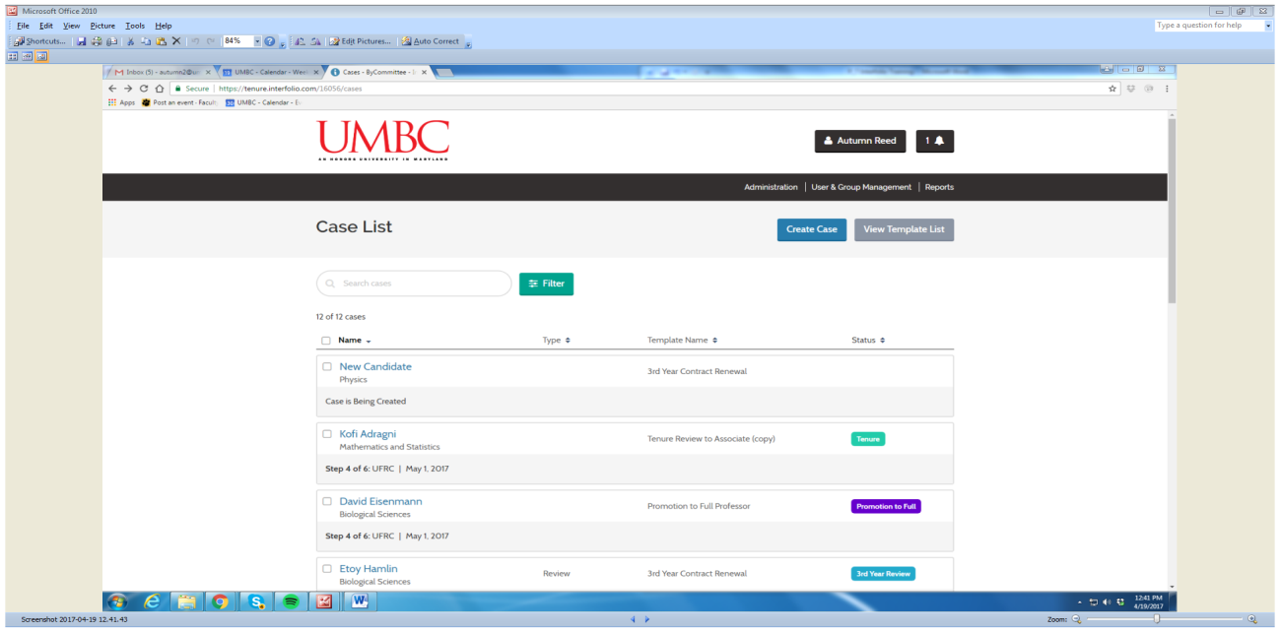

Step 2: Select correct unit (department), if necessary

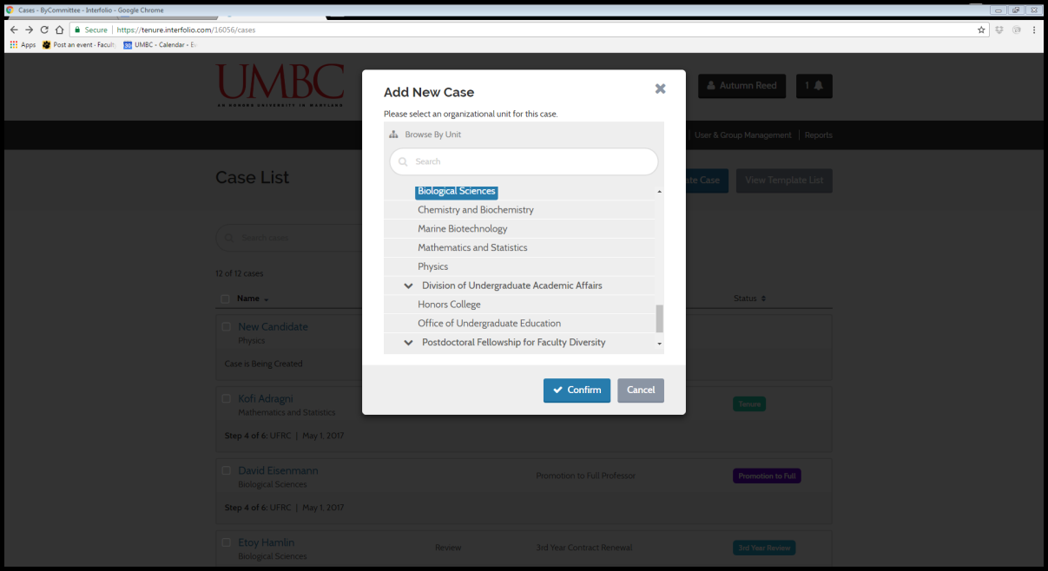

Step 3: Select appropriate template (Review Action)

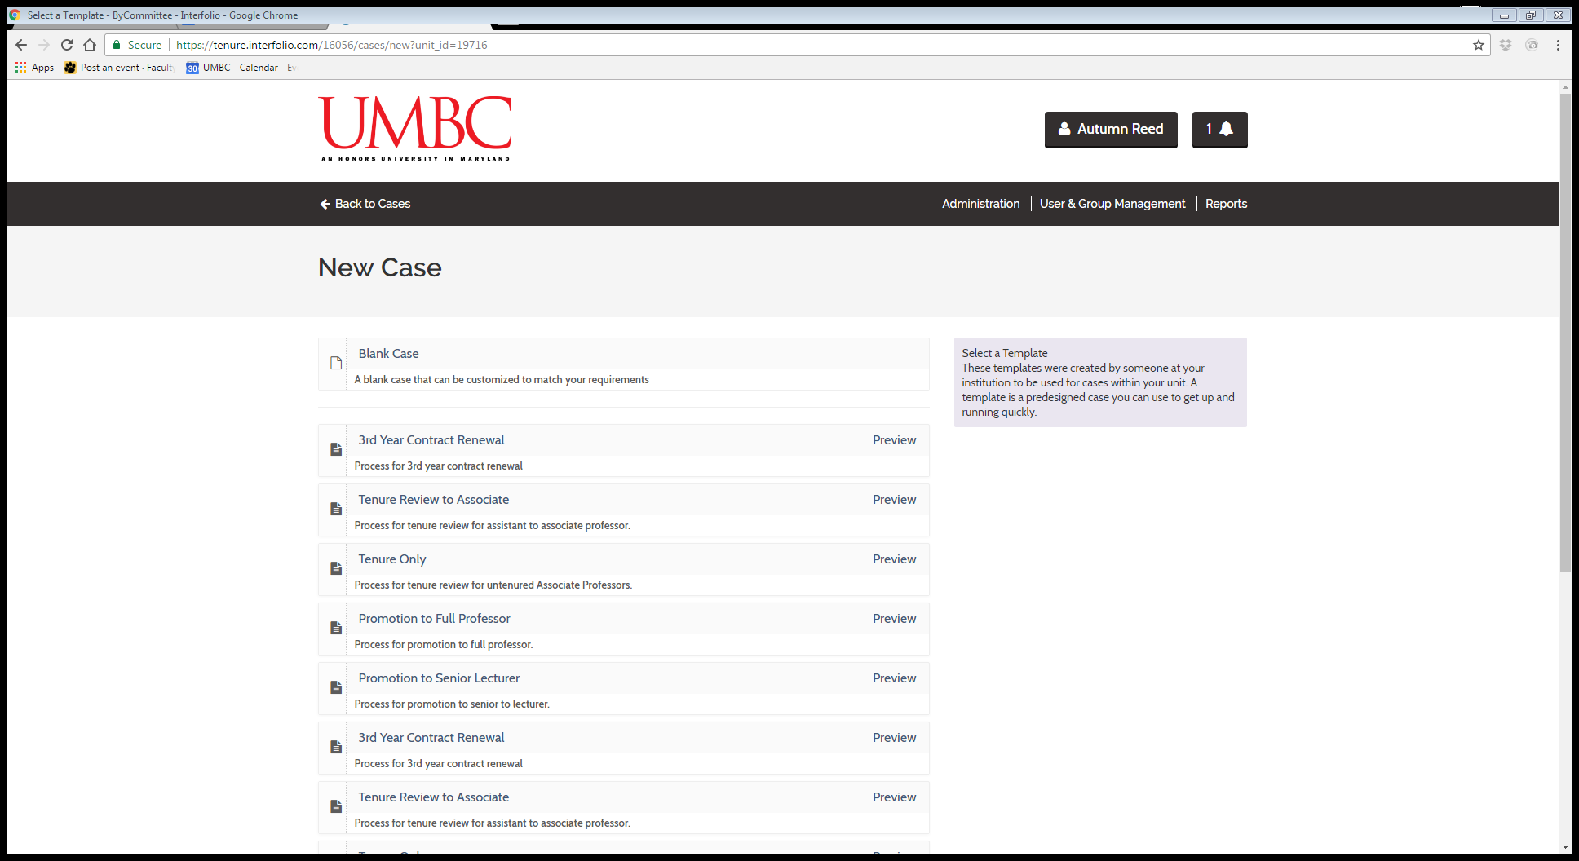
What is a Template???

Step 4: Preview the template to ensure it includes all the necessary 1) Packet (Dossier) Requirements and 2) Case Review Steps (if not you can edit these once inside the template)

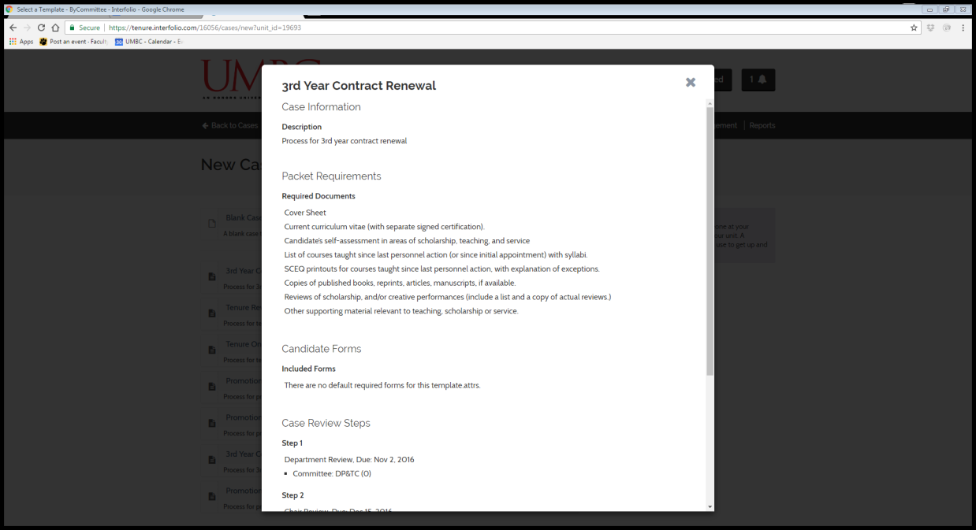

Step 5: After previewing the template, select the appropriate template, which will take you to the Case Information Form

Step 6: The Administrative Assistant complete the Case Information form, which will create the case and notify the candidate to upload their packet (dossier) materials.

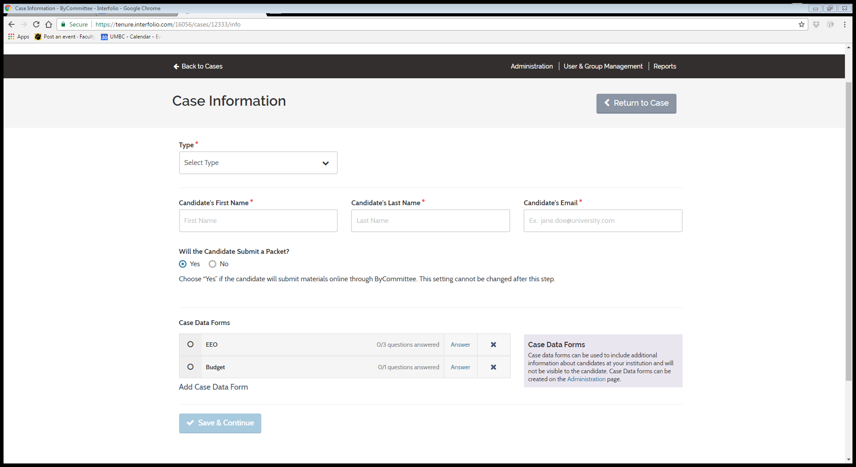
6A. Select the type of action

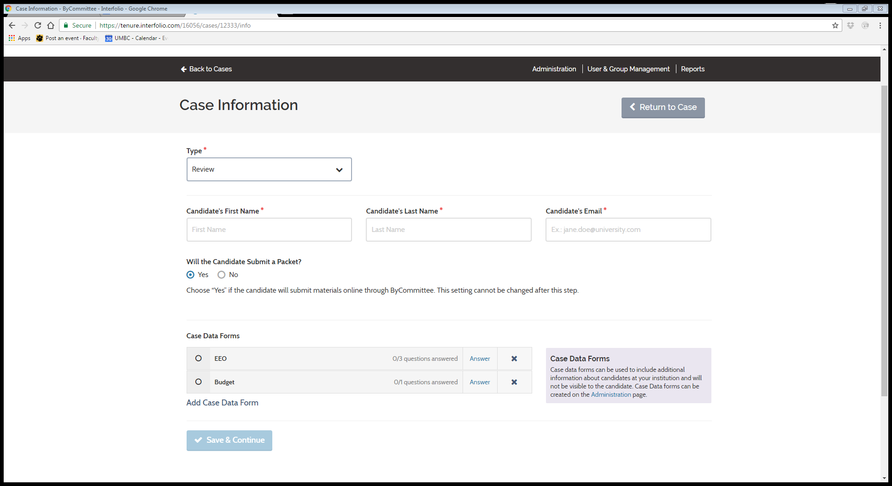

6B. Fill out the Candidate’s First Name, Last Name, and Email (Please make sure this is correct because this action generates the email notification to the candidate to submit their packet (dossier).

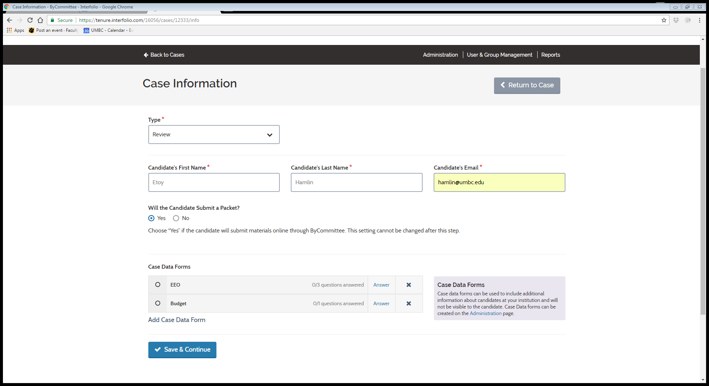

6C. Select “Yes” for the question, “Will the Candidate Submit a Packet?”

6D. Complete the EEO and Budget Case Data forms by selecting “Answer”
These forms are for internal reporting purposes and are not visible to the candidate

EEO Form

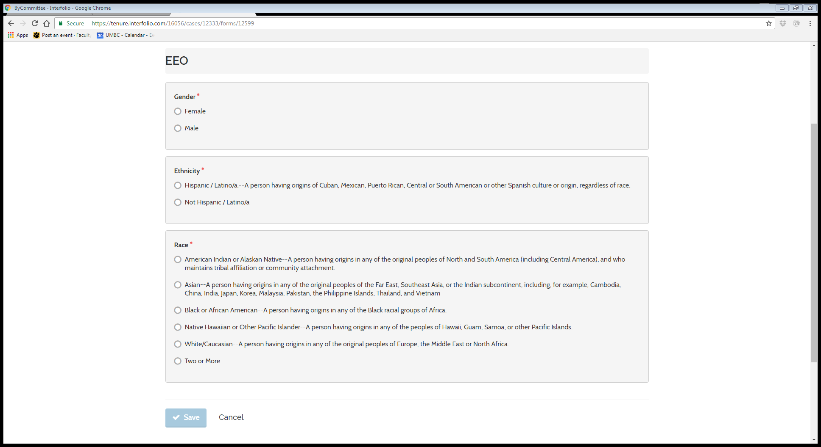

Budget Form

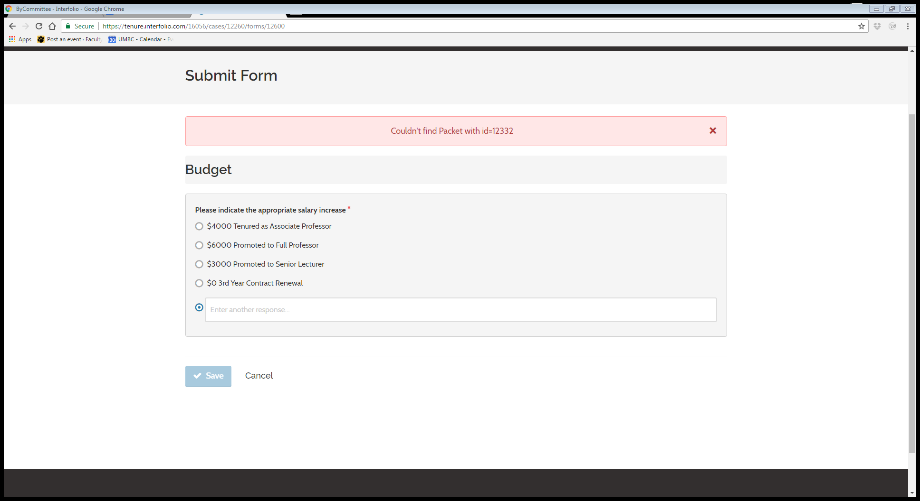

Step 7: Once complete select “Save and Continue”

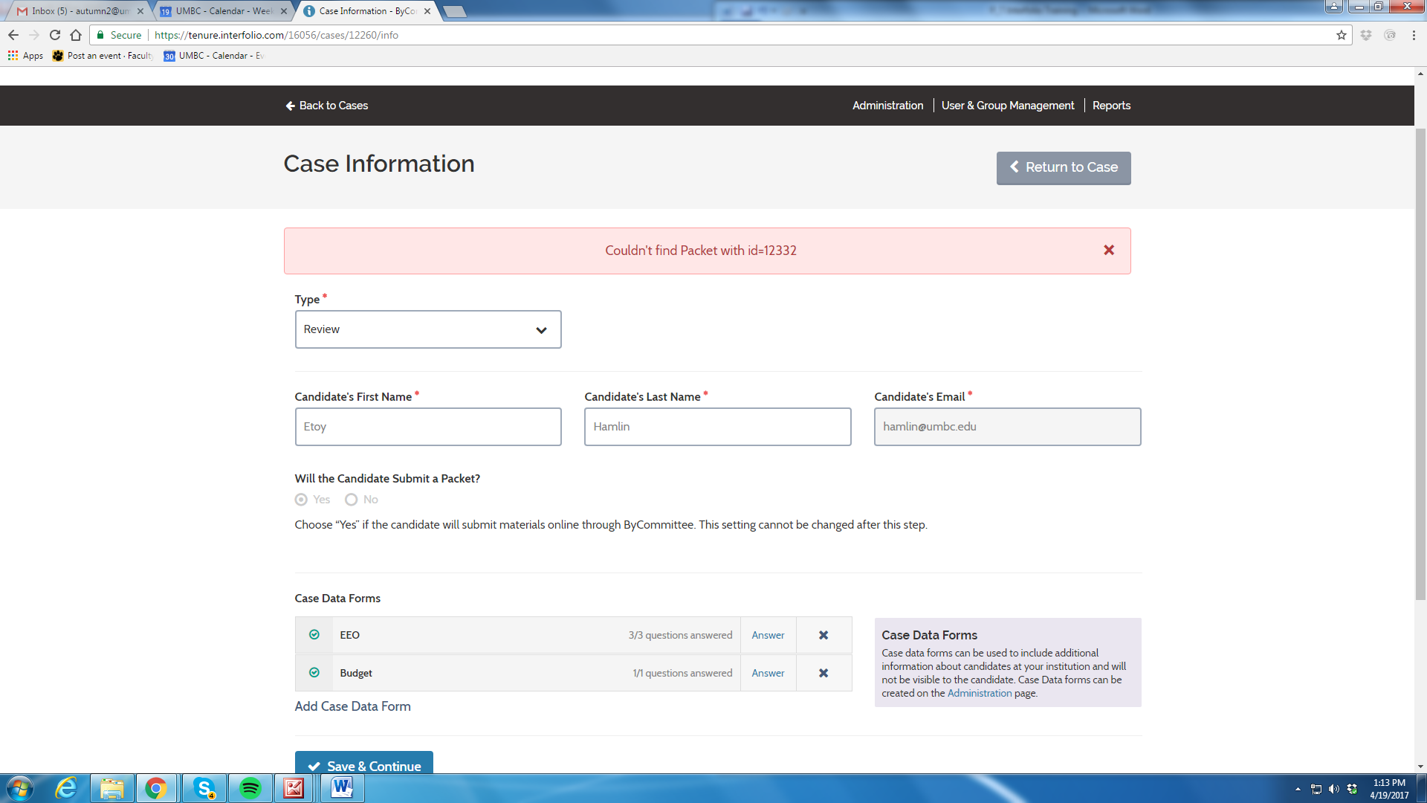

Step 8: Complete the Candidate Requirements section

8A. Enter Candidate Packet due date and enter any instructions to Candidate

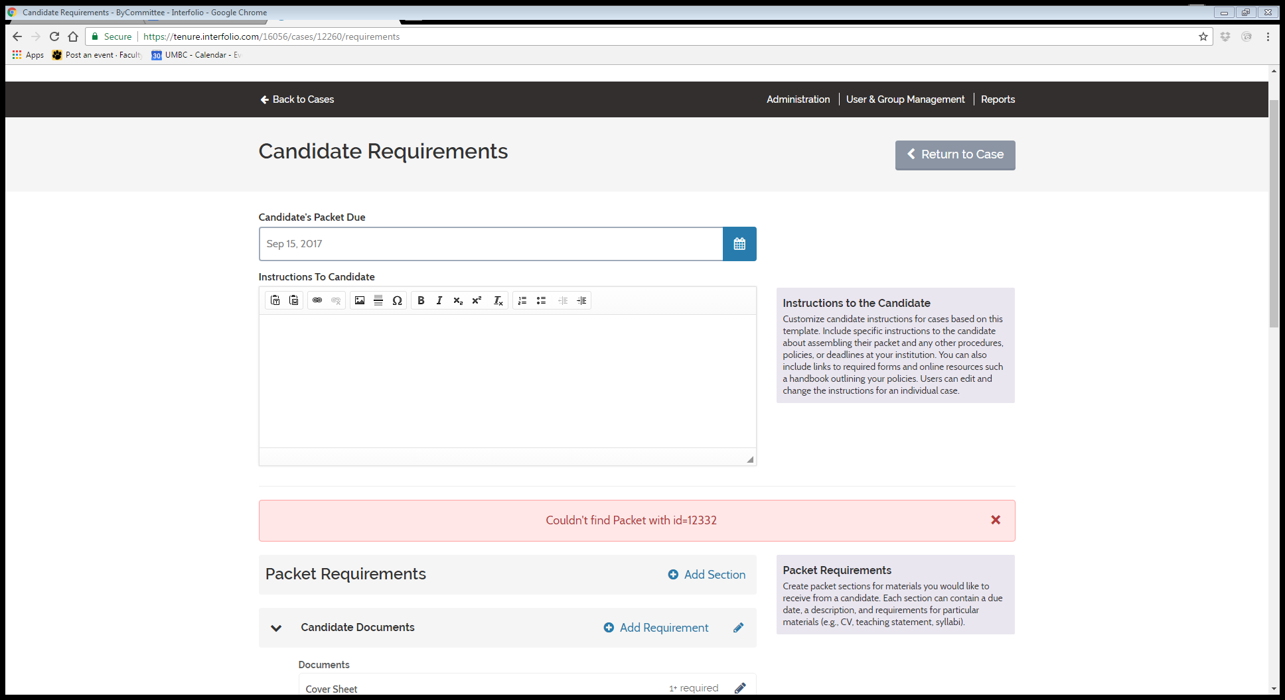

8B. Review Packet (Dossier) Requirements and make any edits that are necessary (these requirements are pre-populated from the template for the review action)

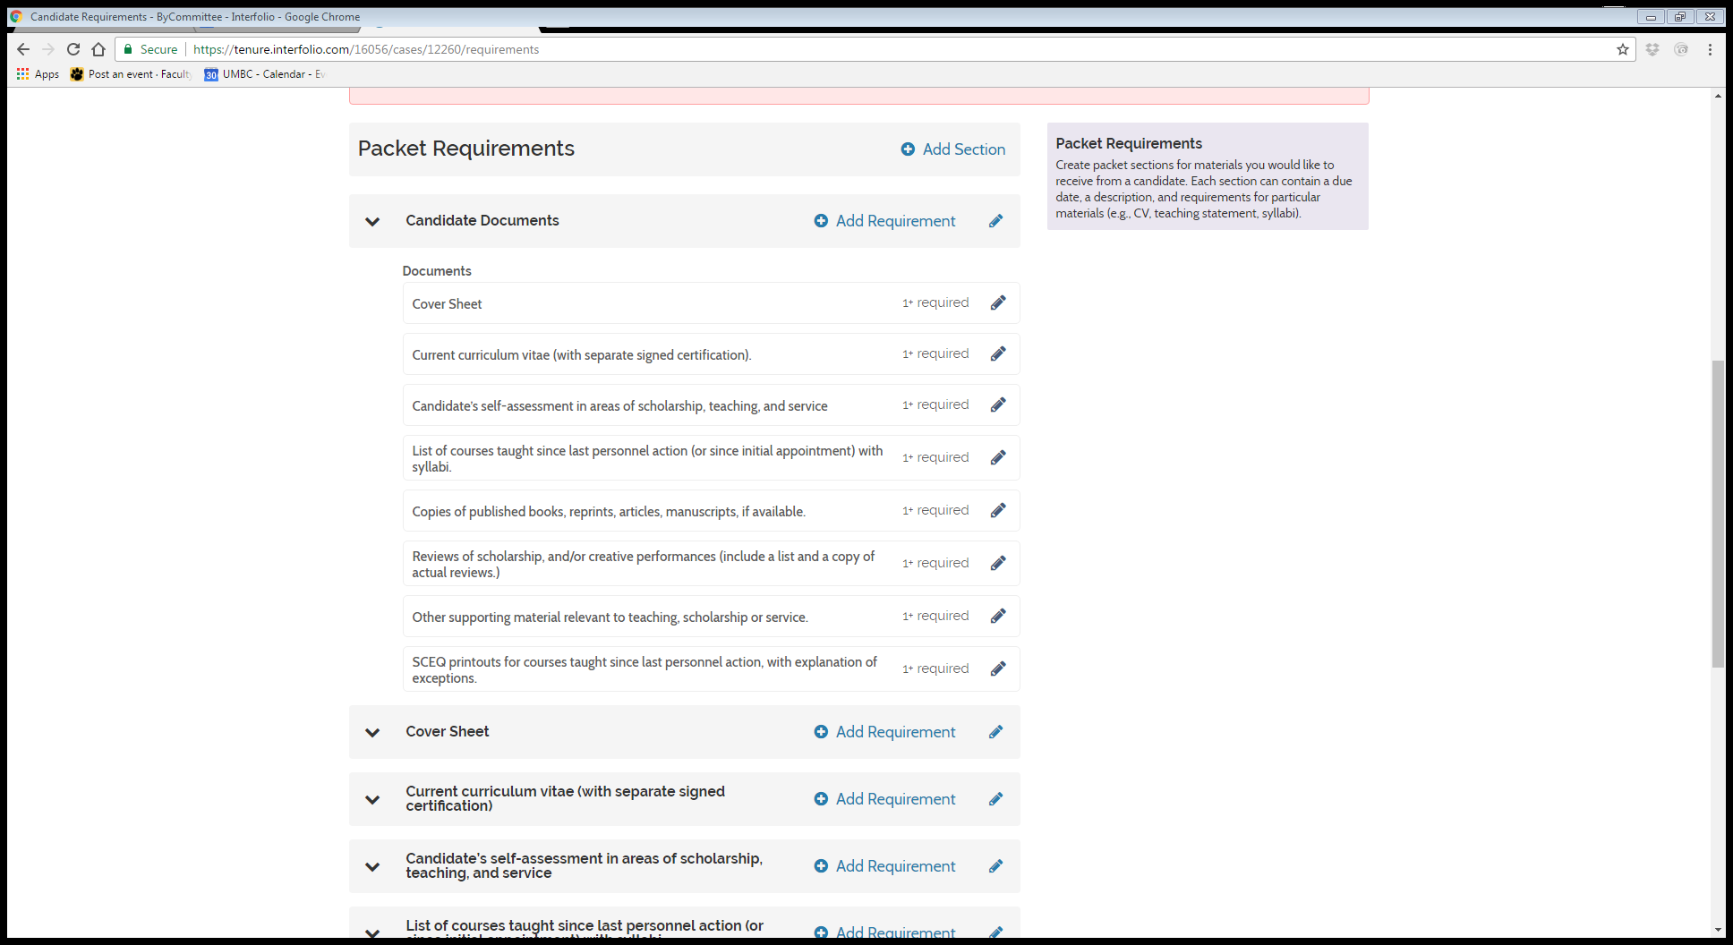

8C. Click “Save & Continue)

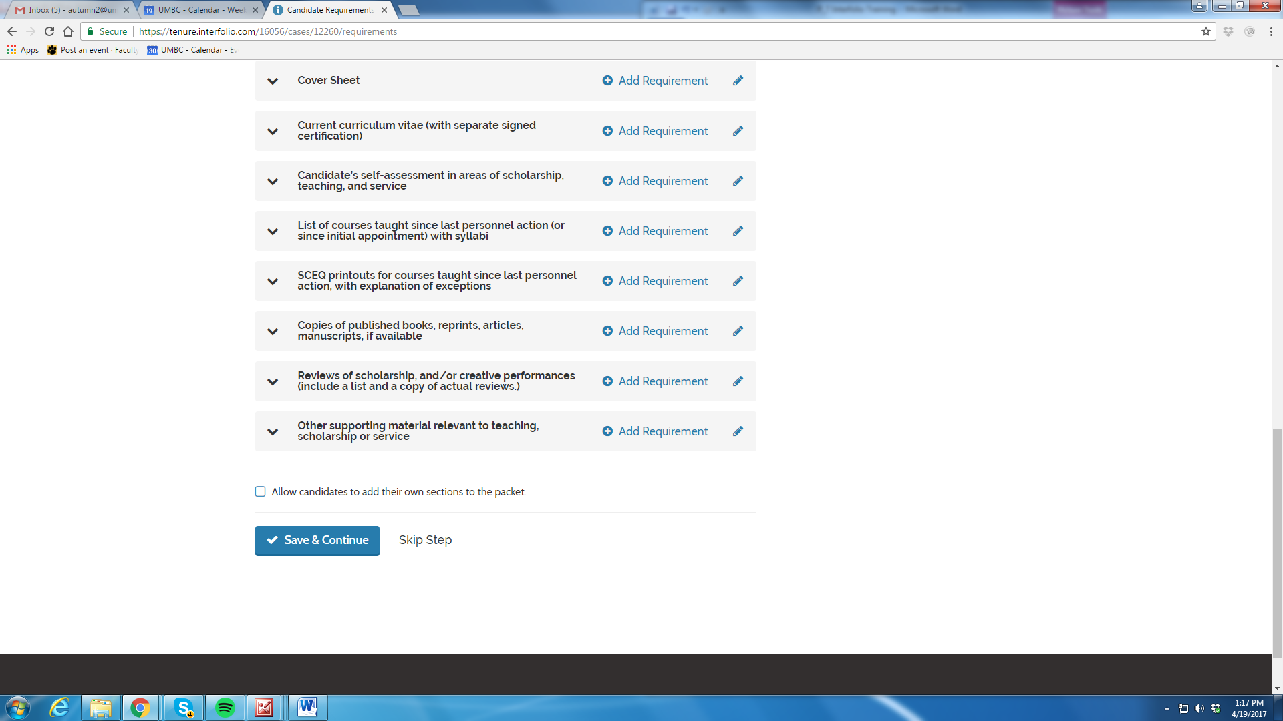

Step 9: Case Review Steps
(This is where you would make any edits that you may have noticed are necessary when you previewed the template)

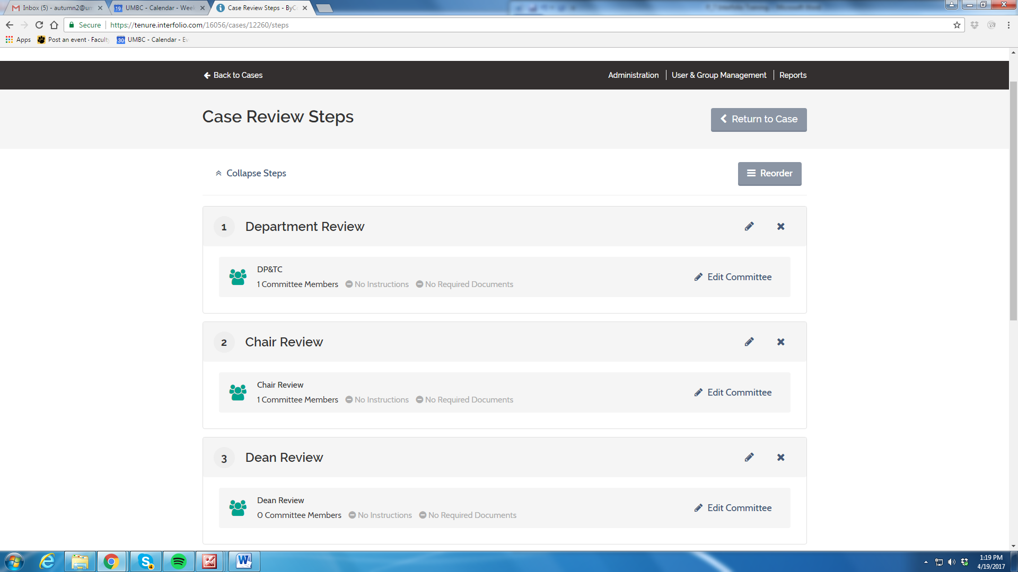
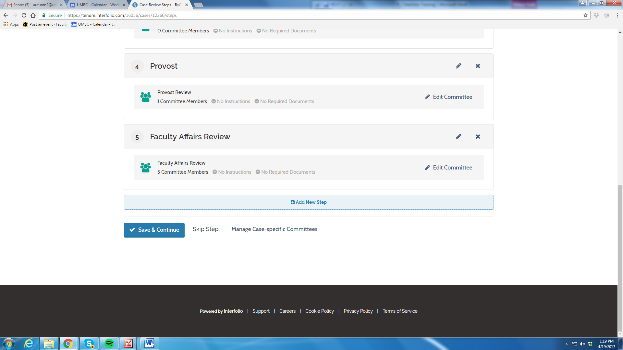

9A. Ensure that Review Levels are present and in the correct order
If needed you can:

*Reorder the steps

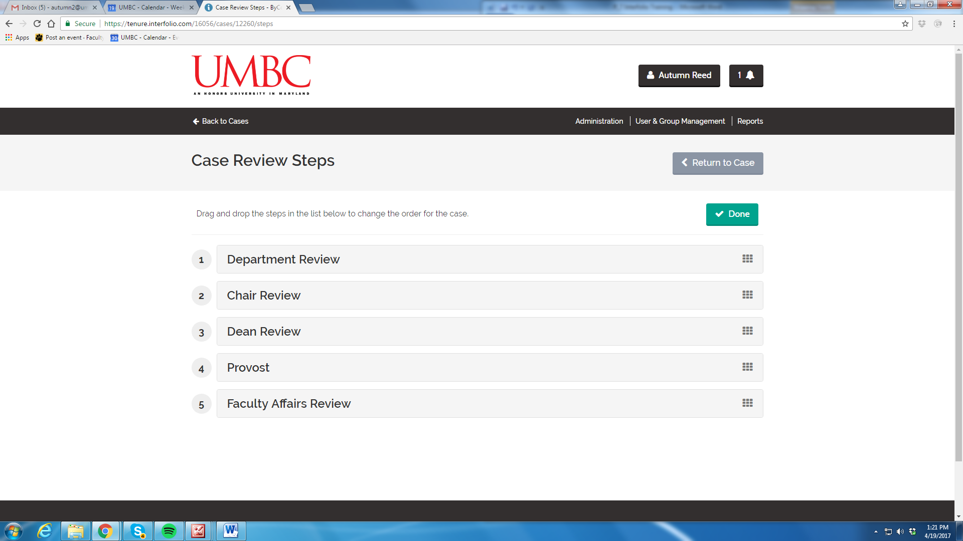

*Add a new step

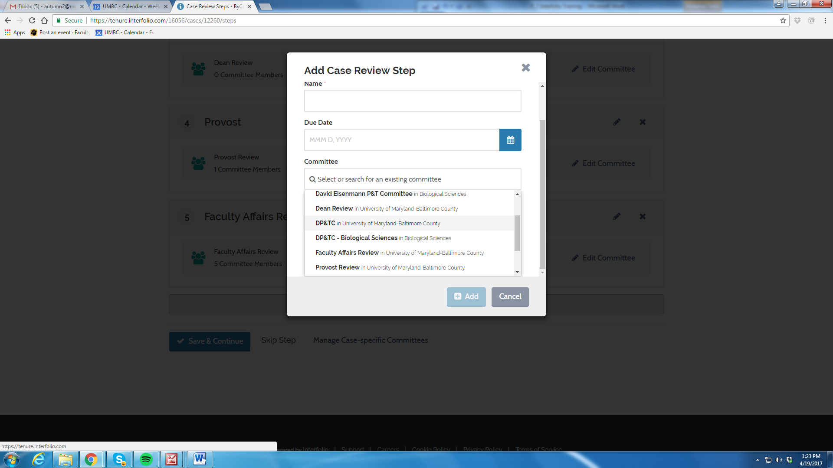

Step 10: Edit and Add Committee Members for
*Department Review (DP&TC)
*Chair Review
*Dean Review
NB: The Provost, UFRC, and Faculty Affairs Review Levels are Standing Committees that are generated by the Office of Provost and Departments are unable to edit membership in these pre-populated levels. Recusals in the UFRC will be handled by Ms. Etoy Hamlin.

All faculty should already be the Interfolio system for you to add

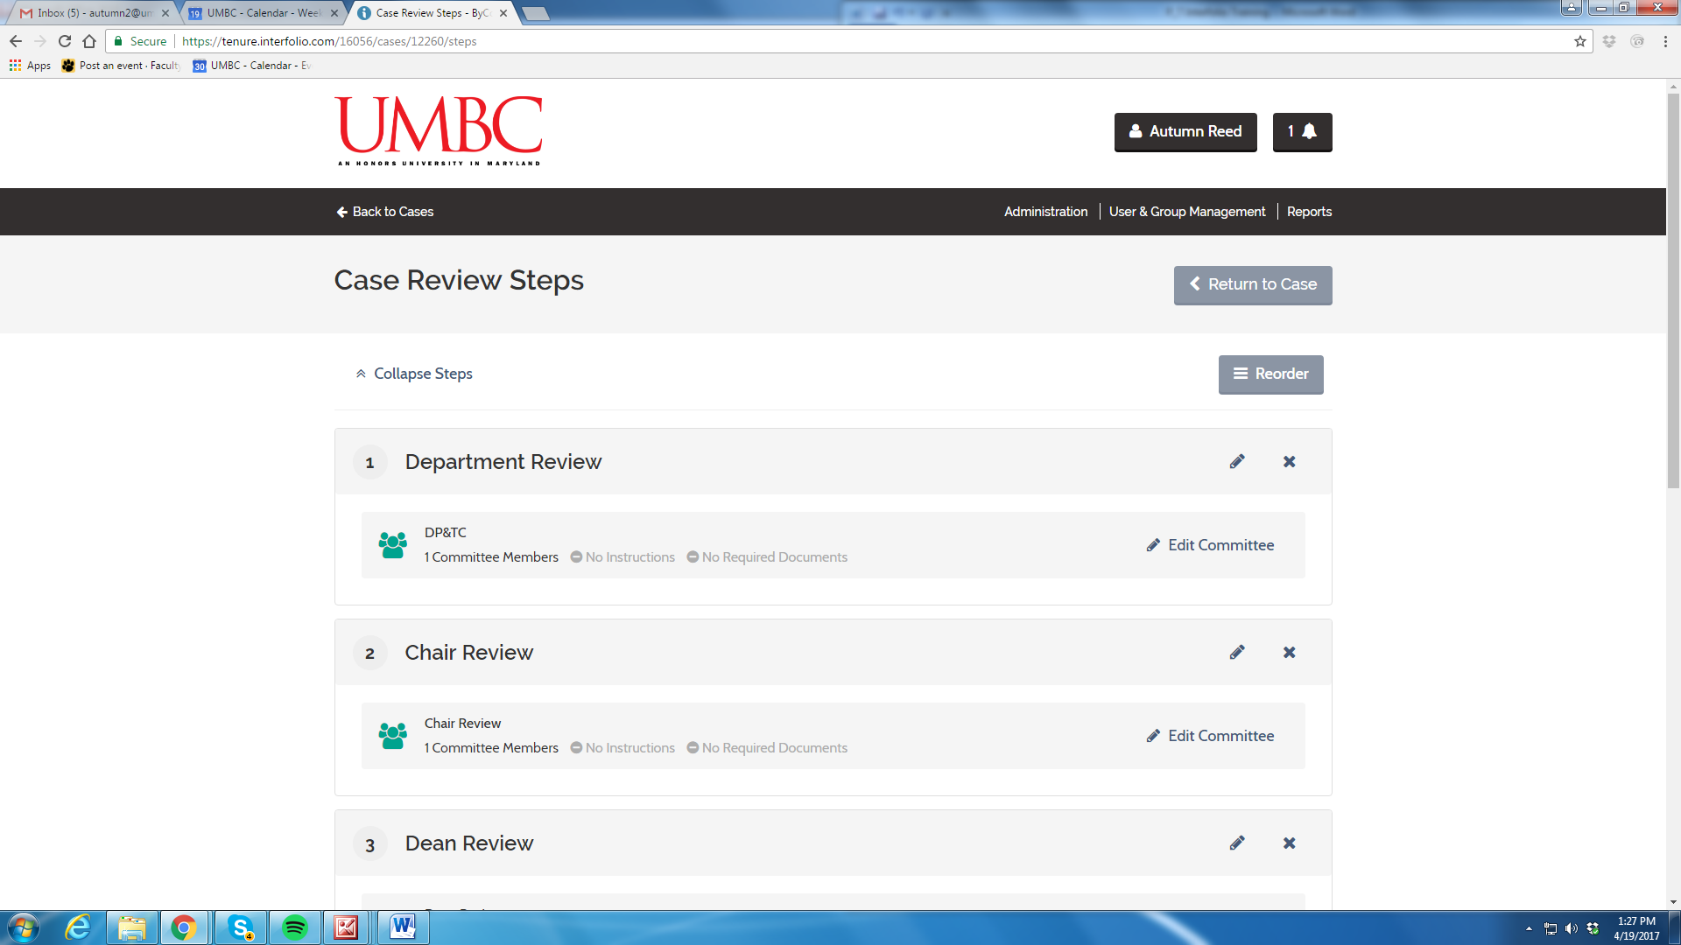
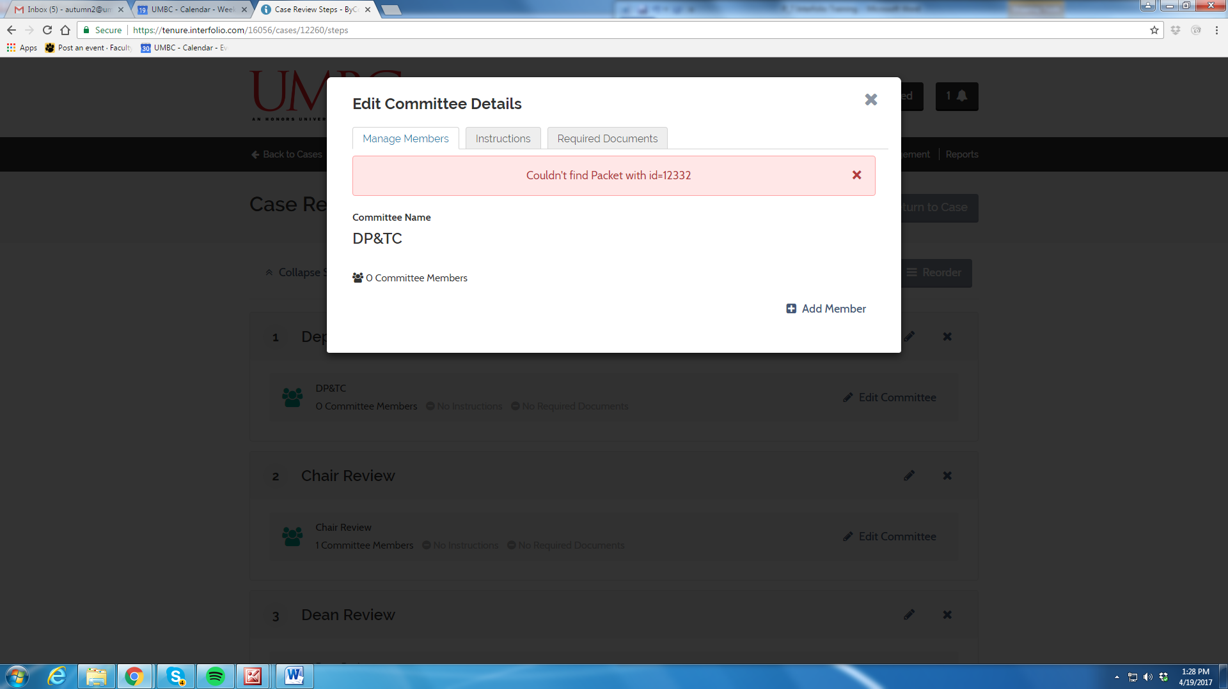

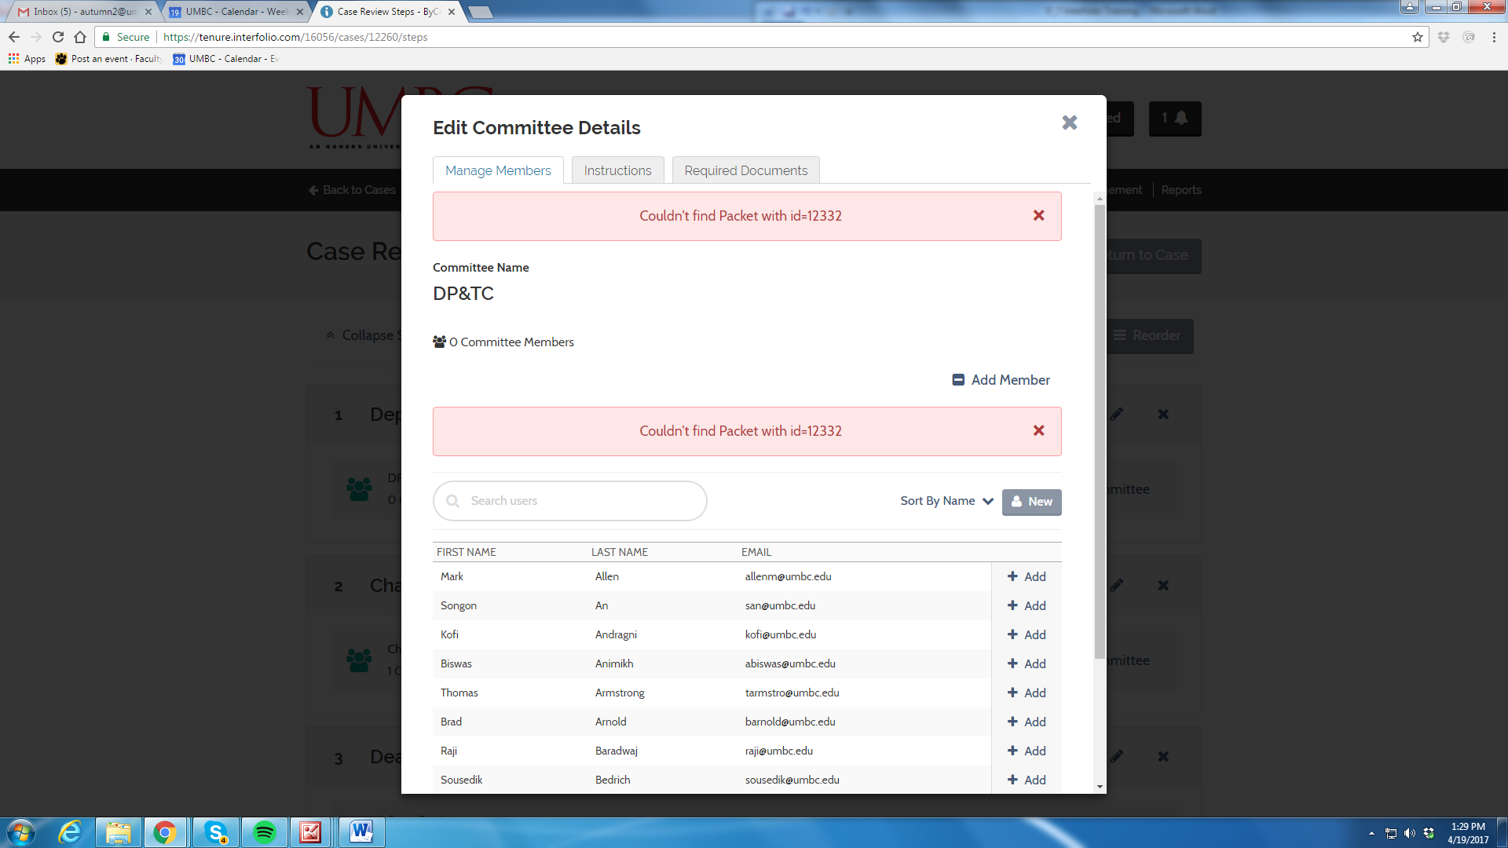

Select “Save & Continue”
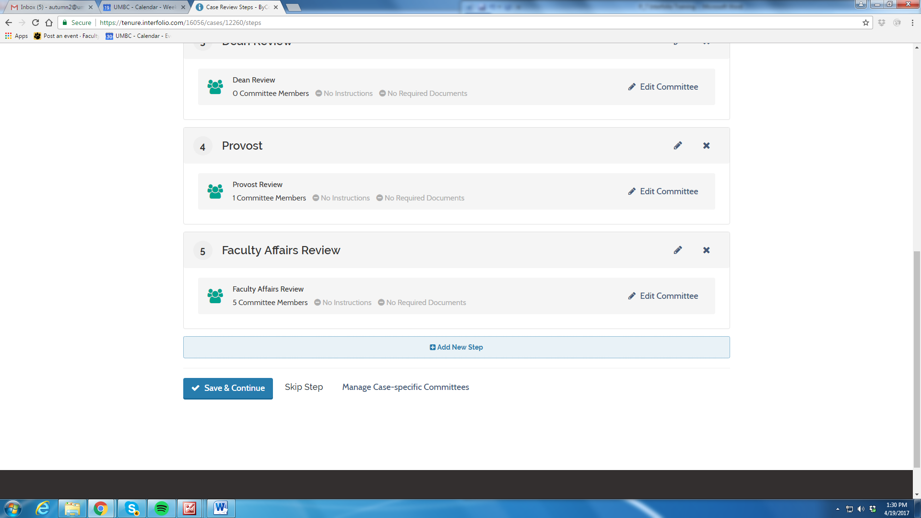

Step 11: Review Case Summary for completeness and accuracy

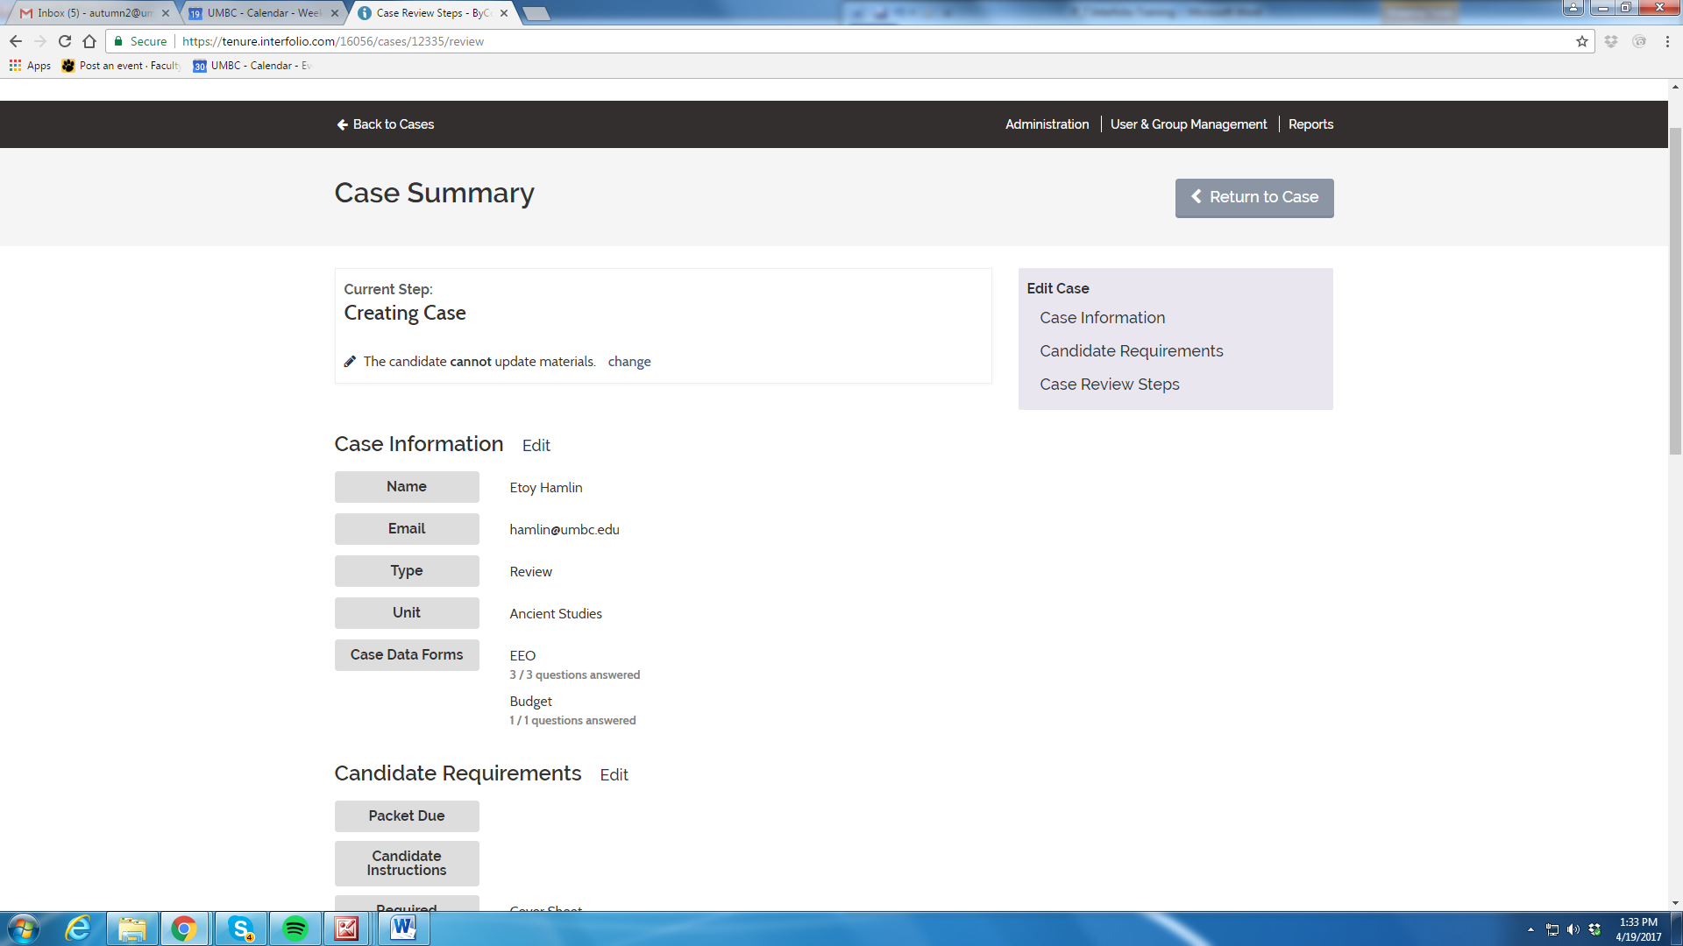

Step 12: Select “Return to Case”

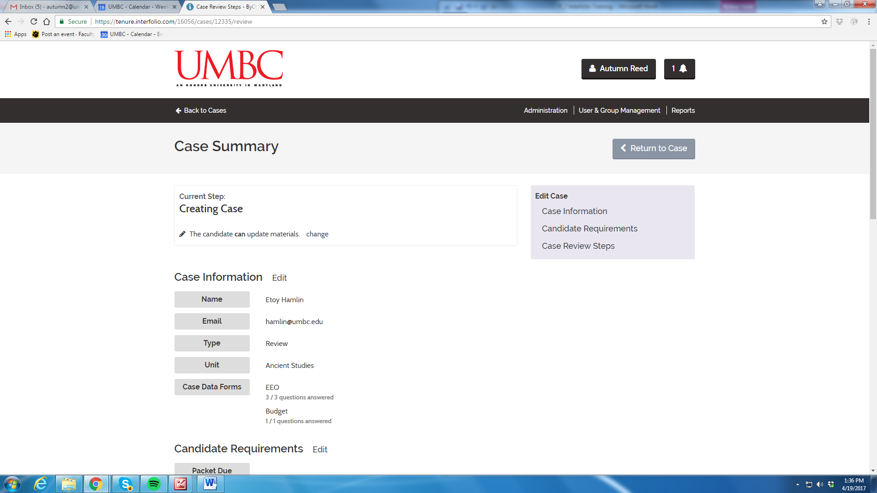
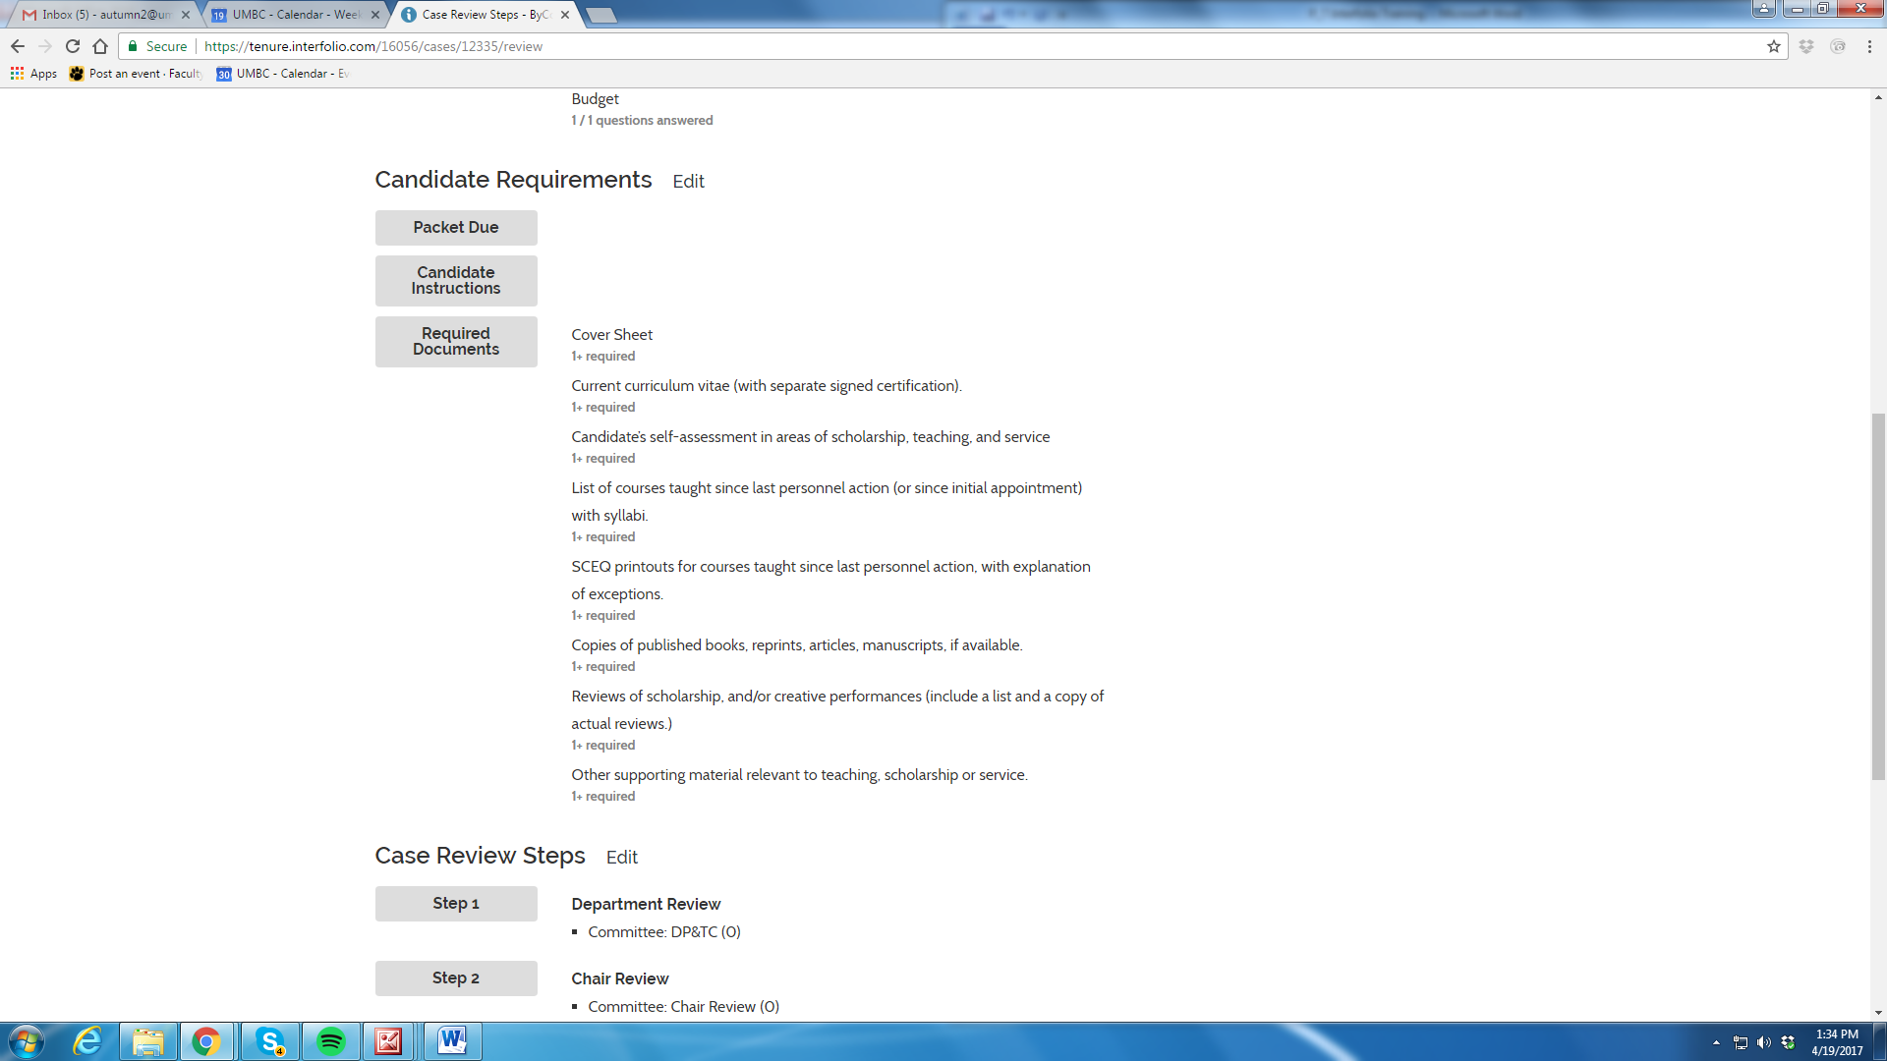
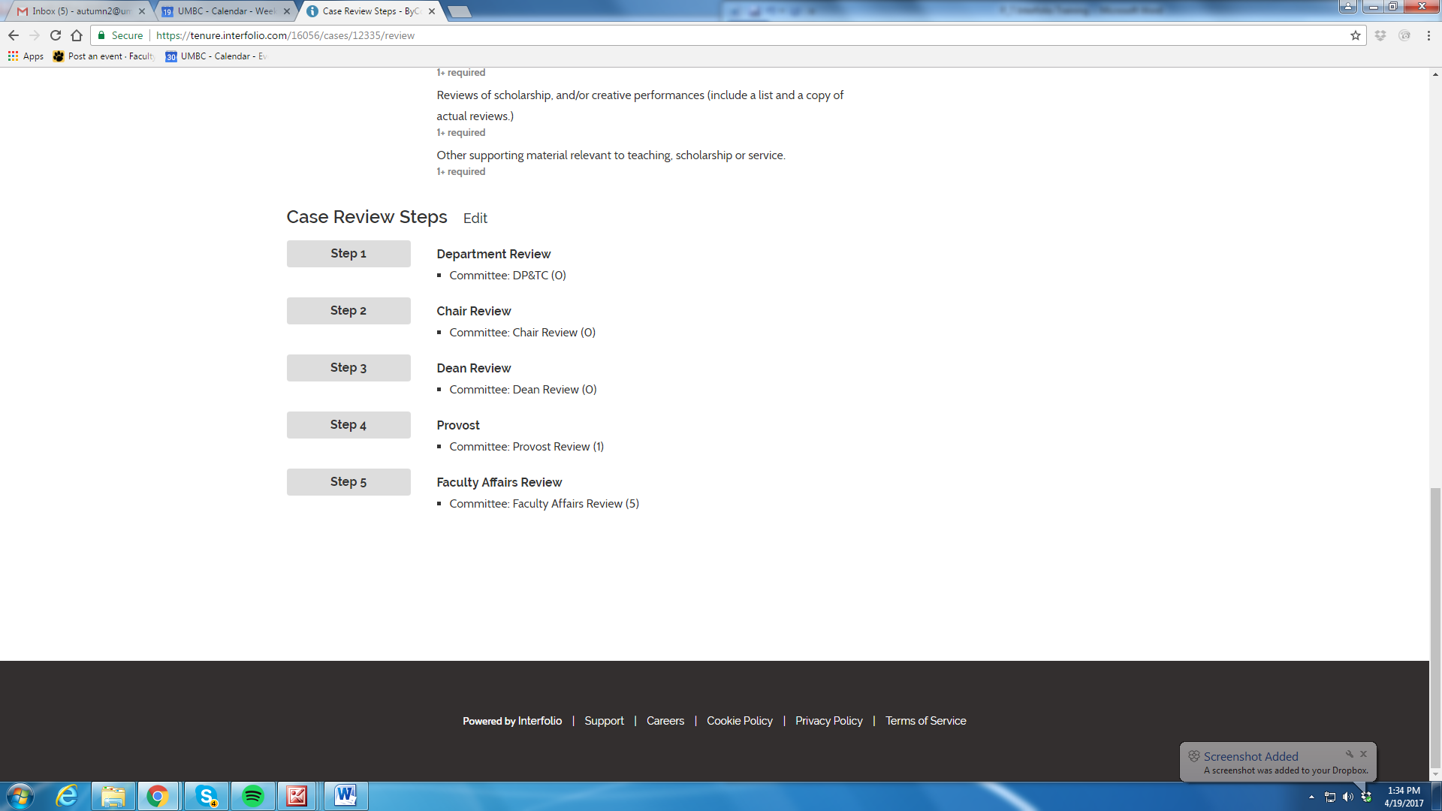

Step 13: Notify candidate of Case Creation (This sends the email with instructions on how to submit a packet (Dossier)

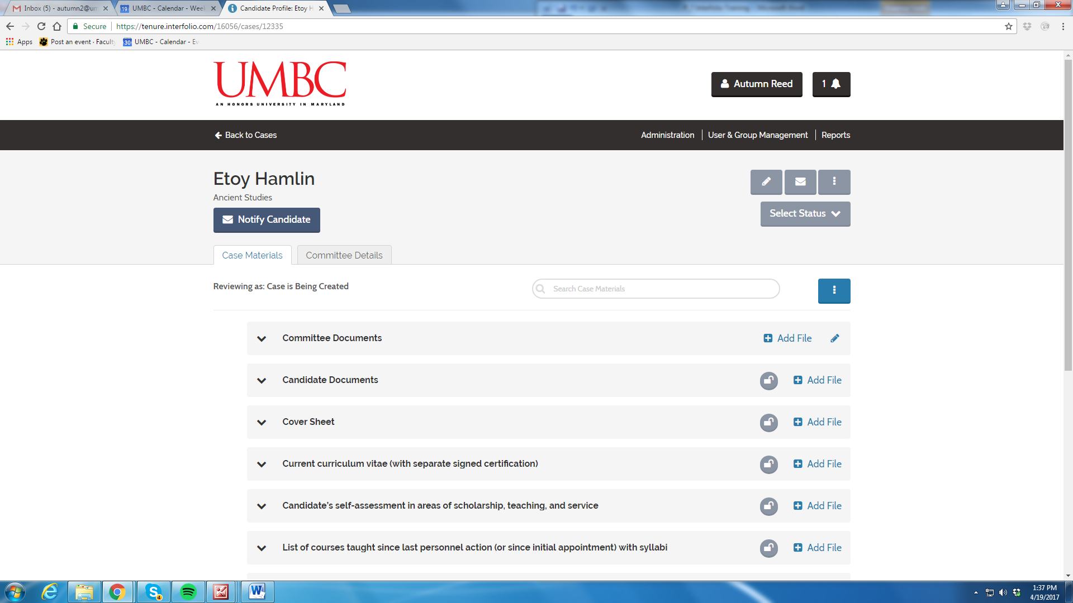

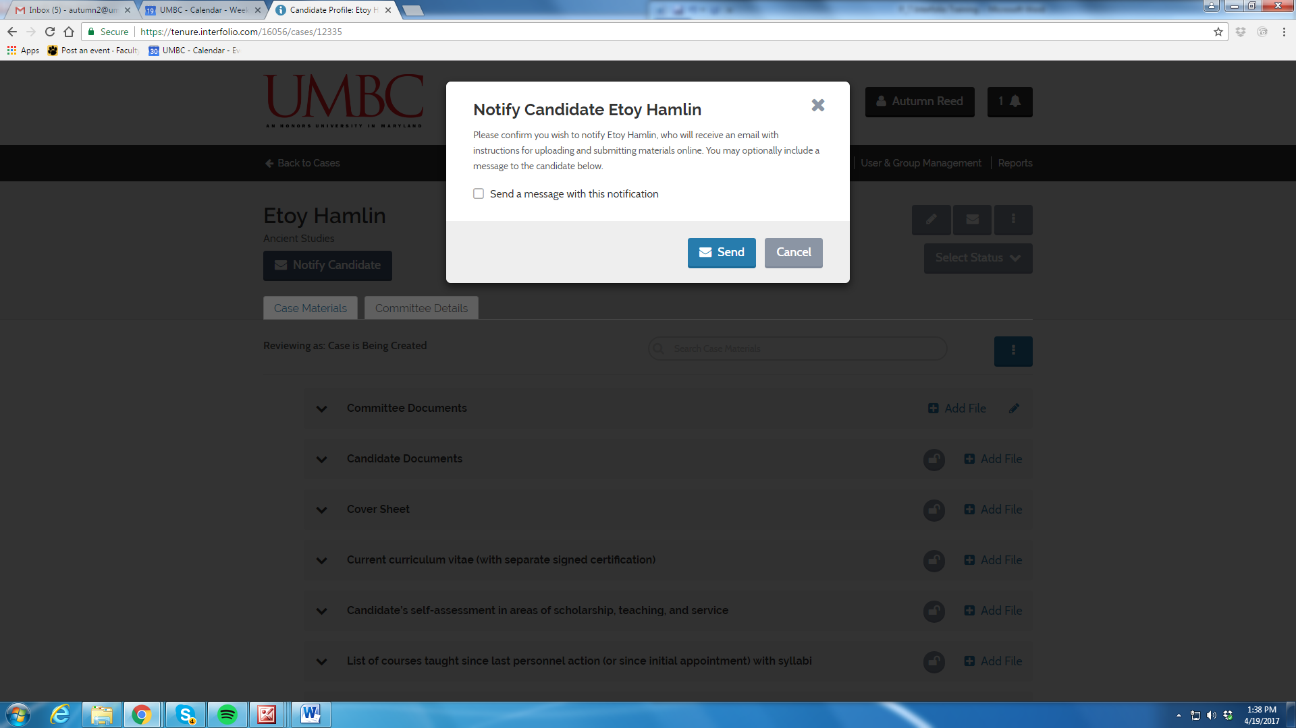

Step 14: Select Status
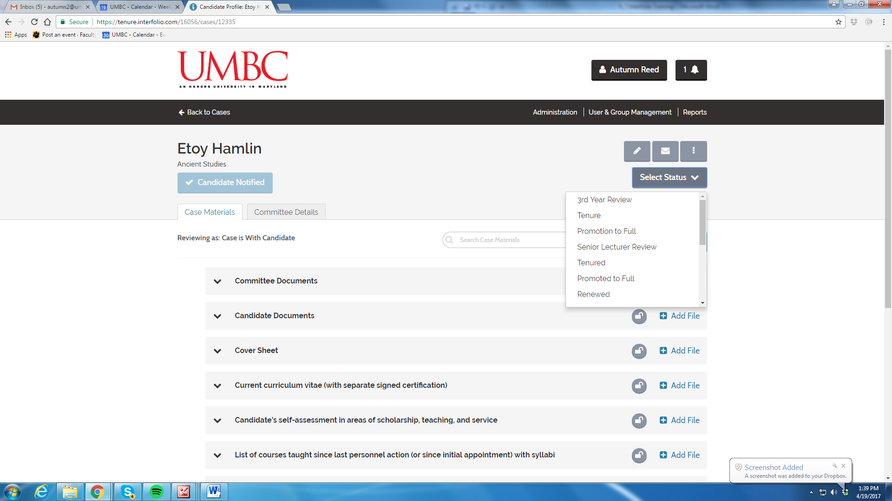

Other Functions:
Candidate Information
You can review the Case Materials
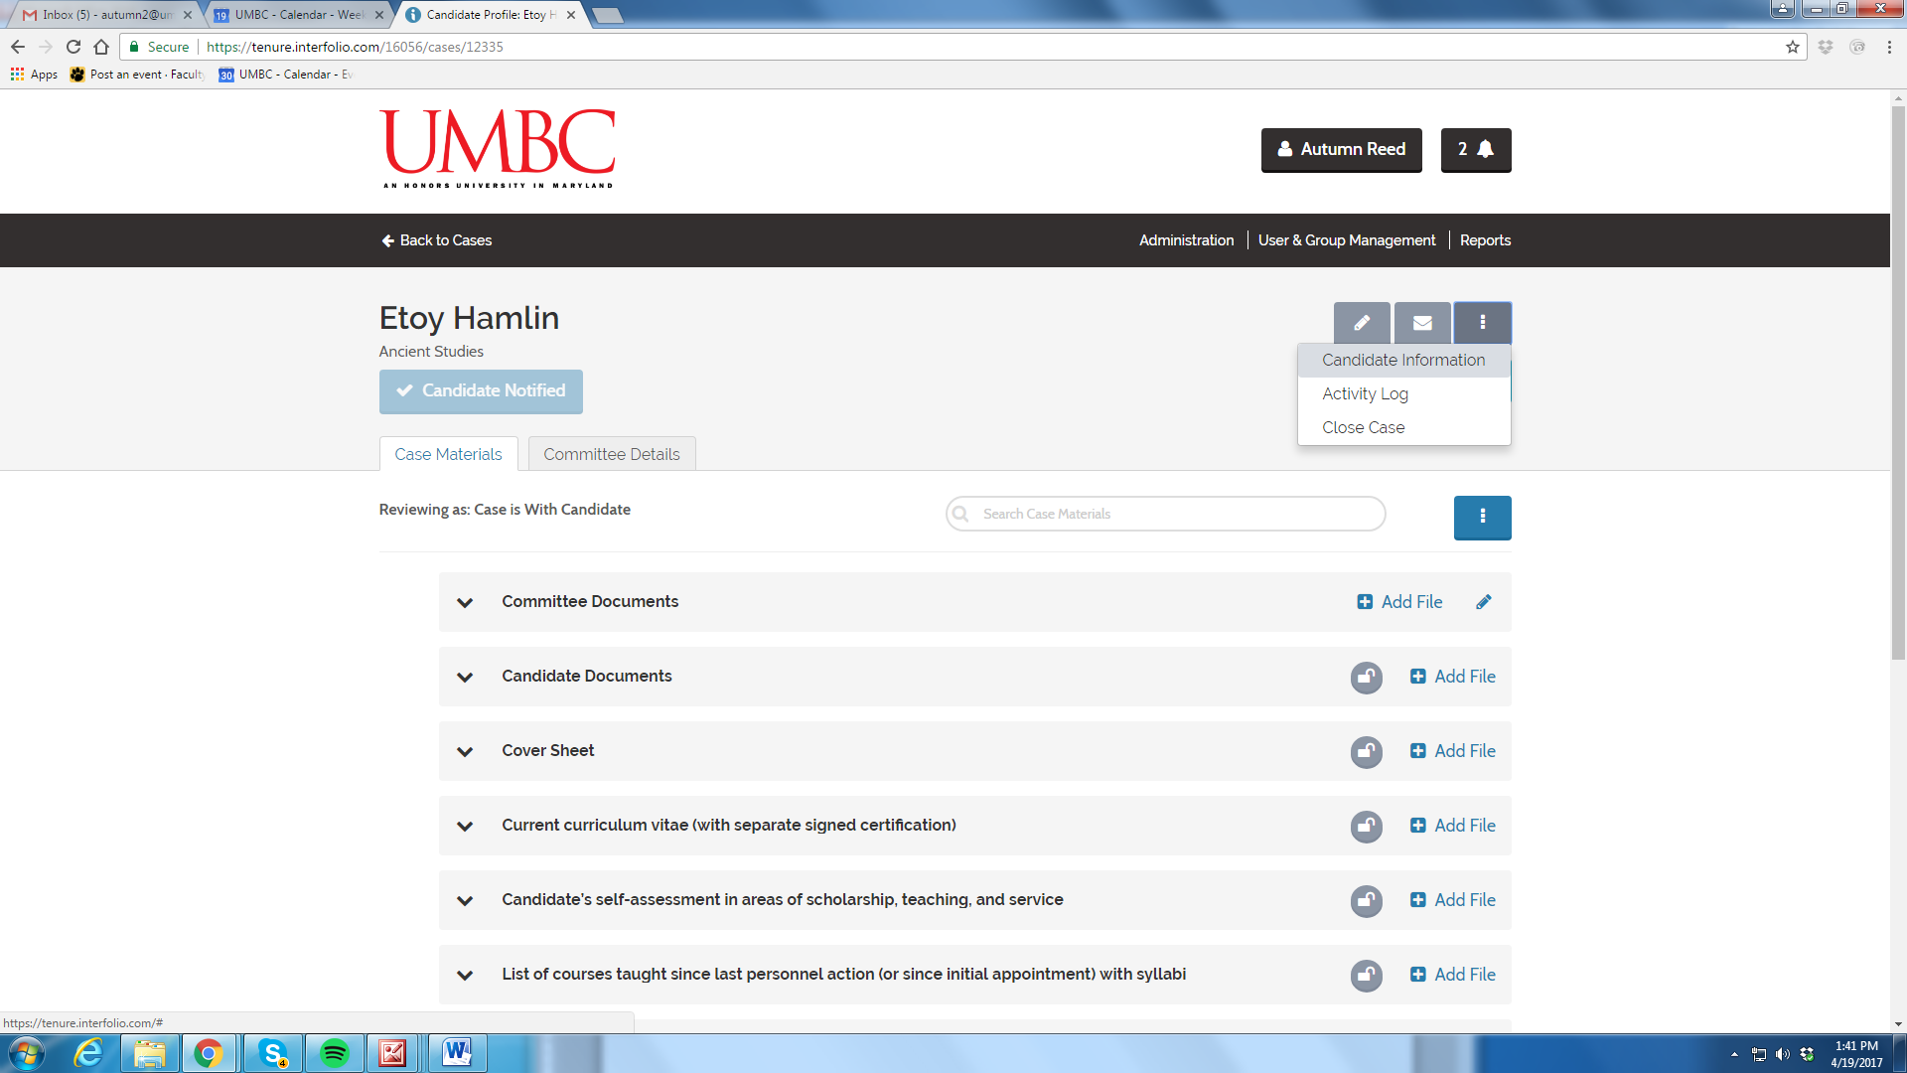
You can also review the Committee Details

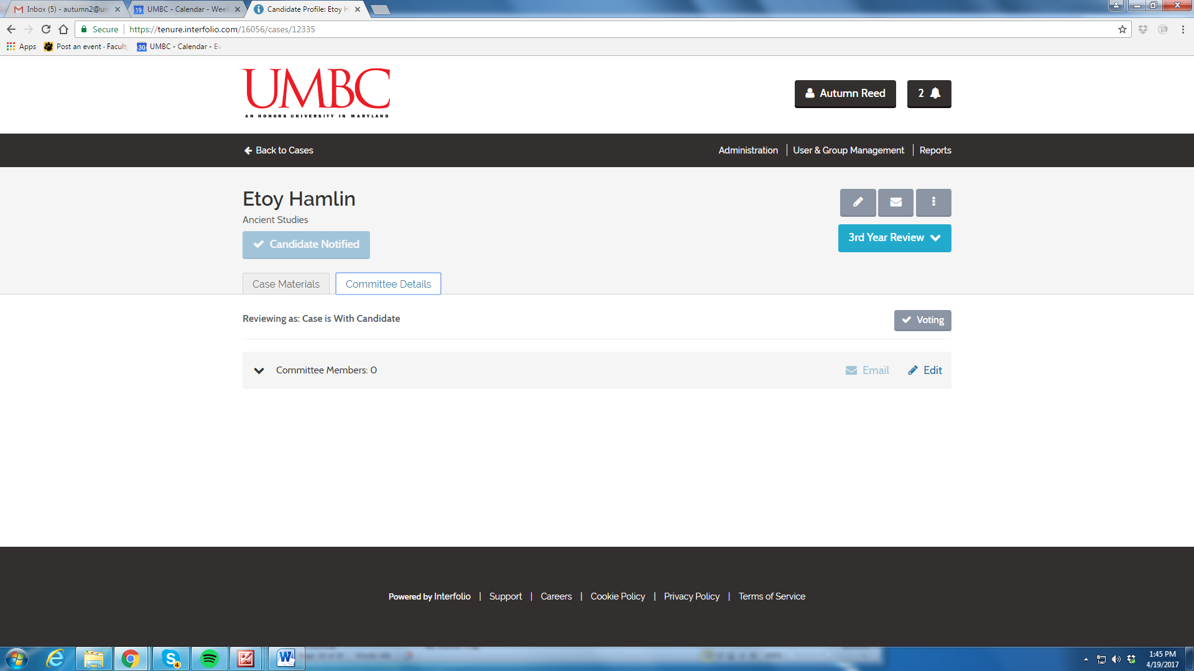

Activity Log
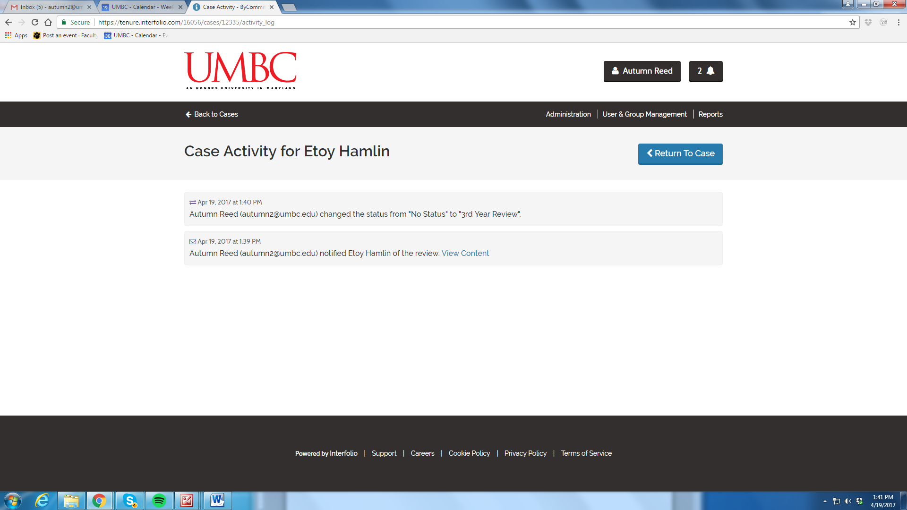

Close Case
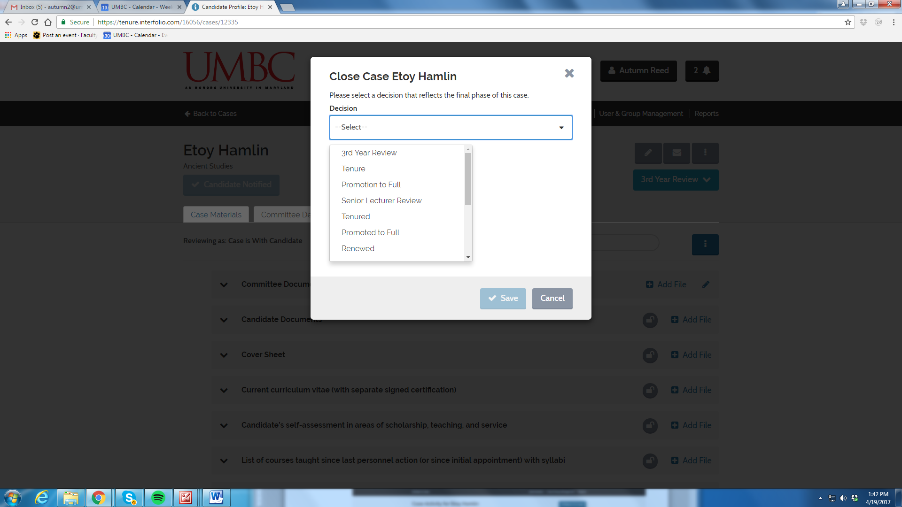

Edit Case
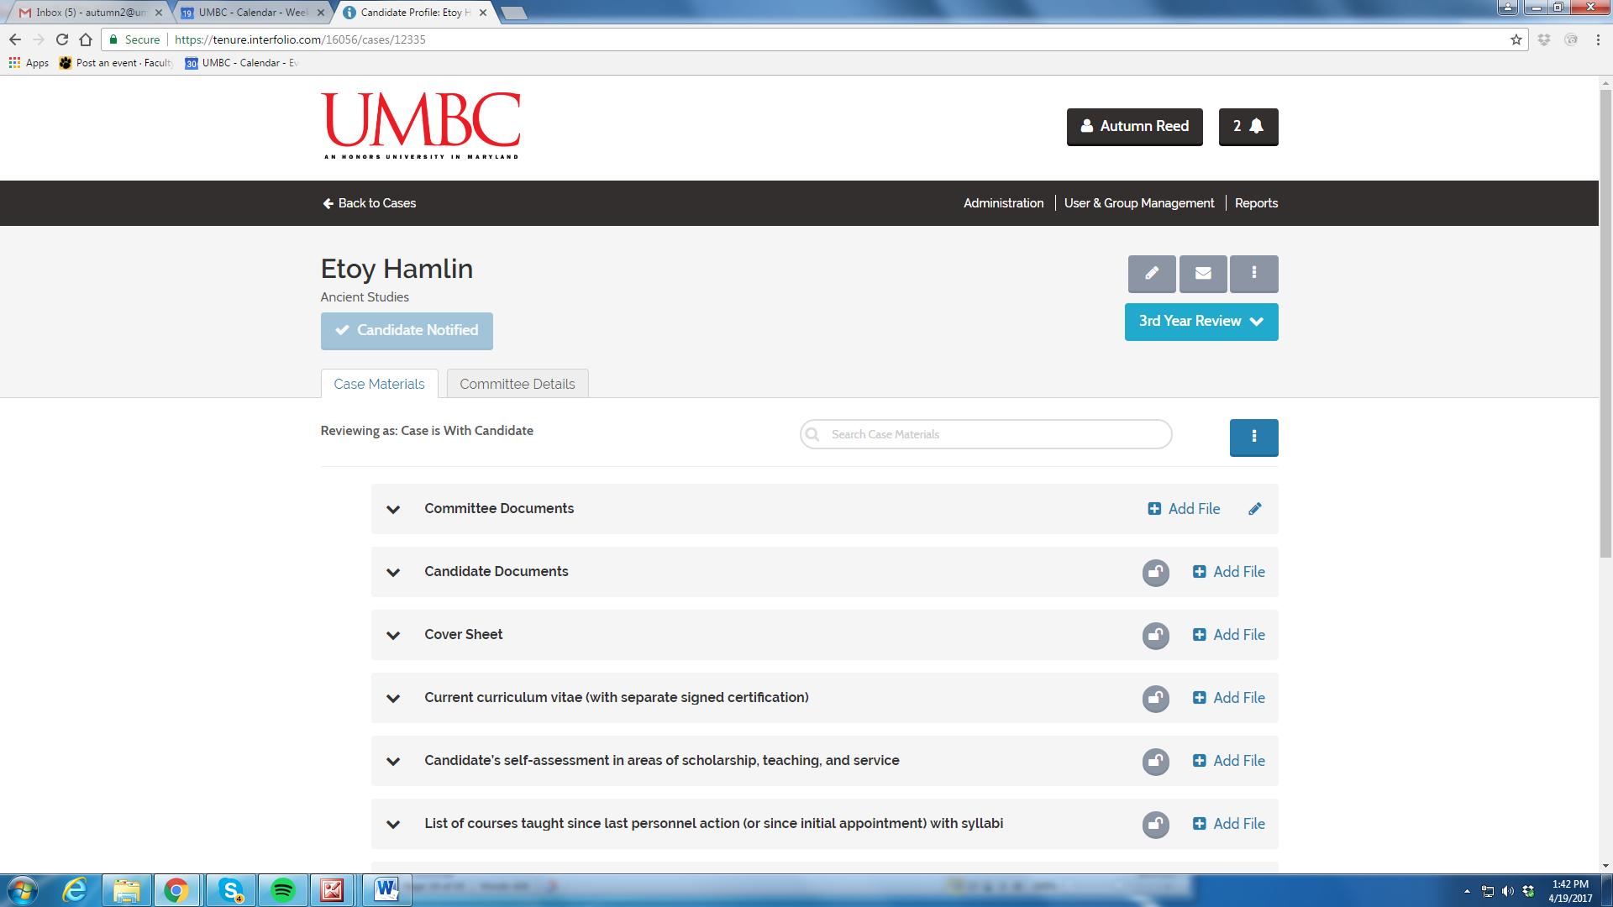

Email Candidate
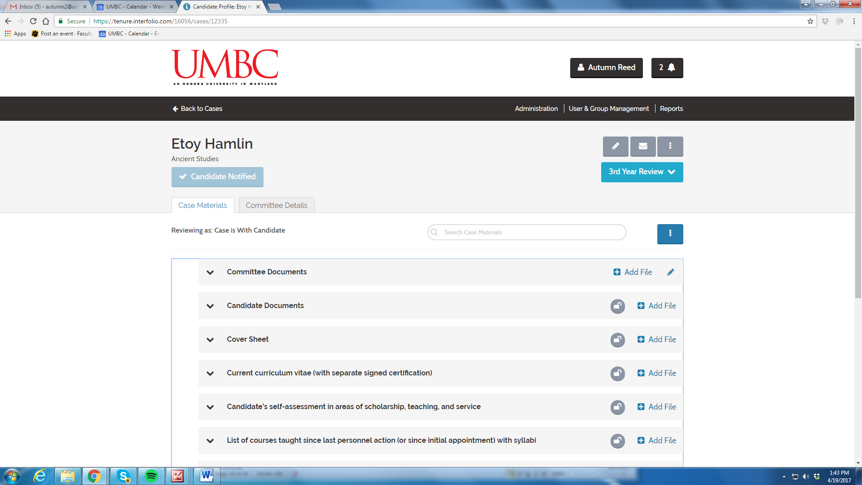

- Candidate Packet (Dossier) Uploading

Step 1: Email from Interfolio (You generated this when you created the case)

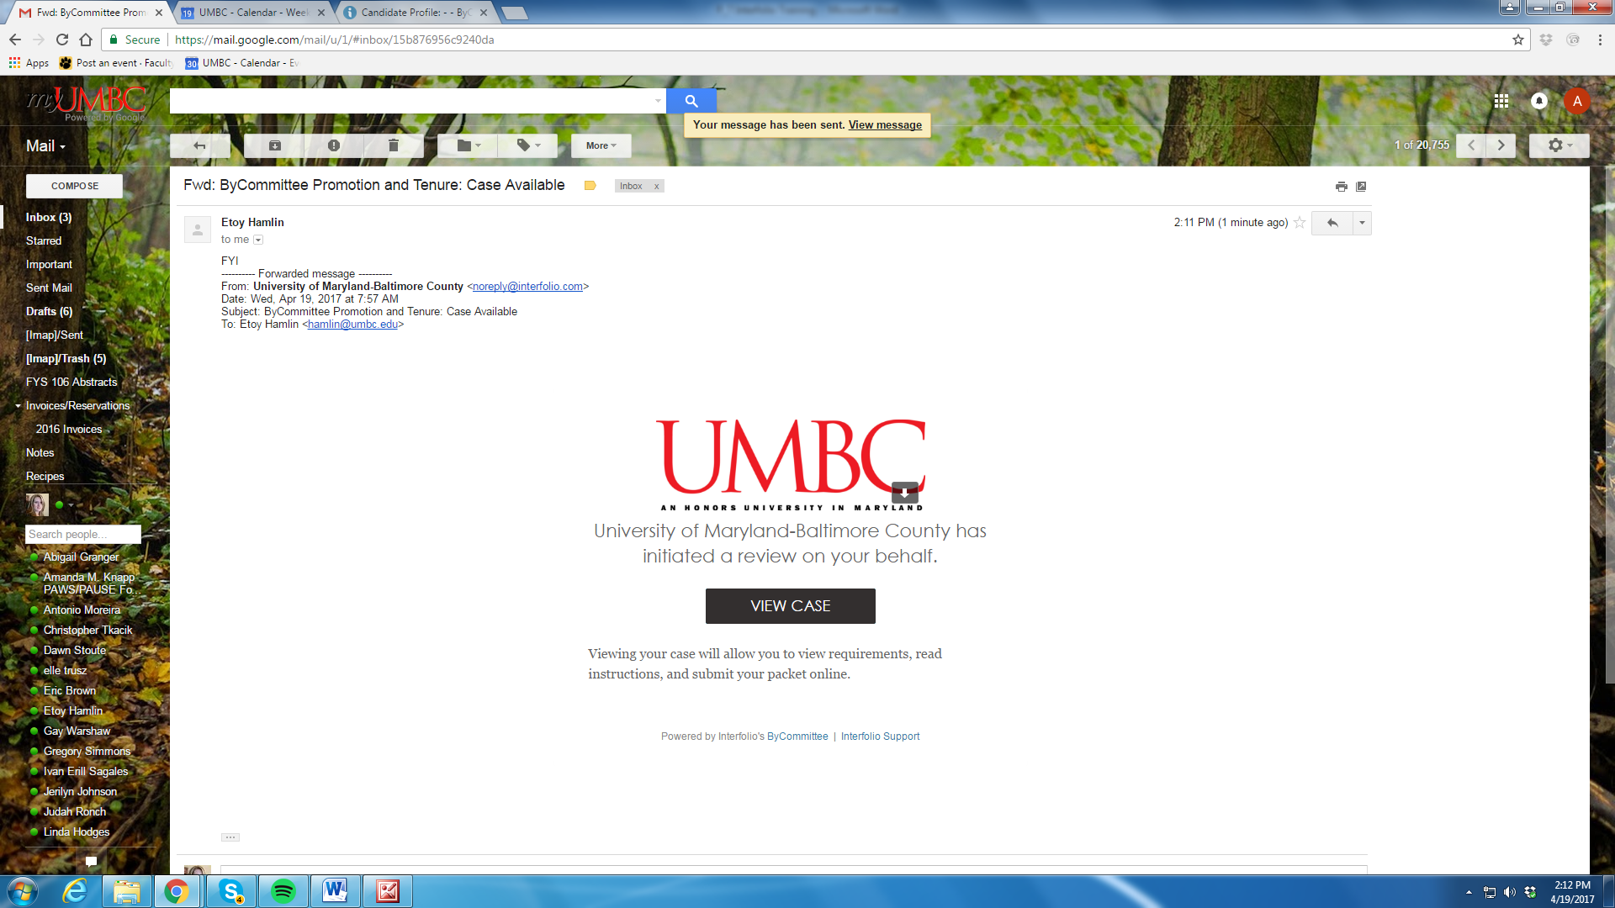

Step 2: Candidate logs into Interfolio

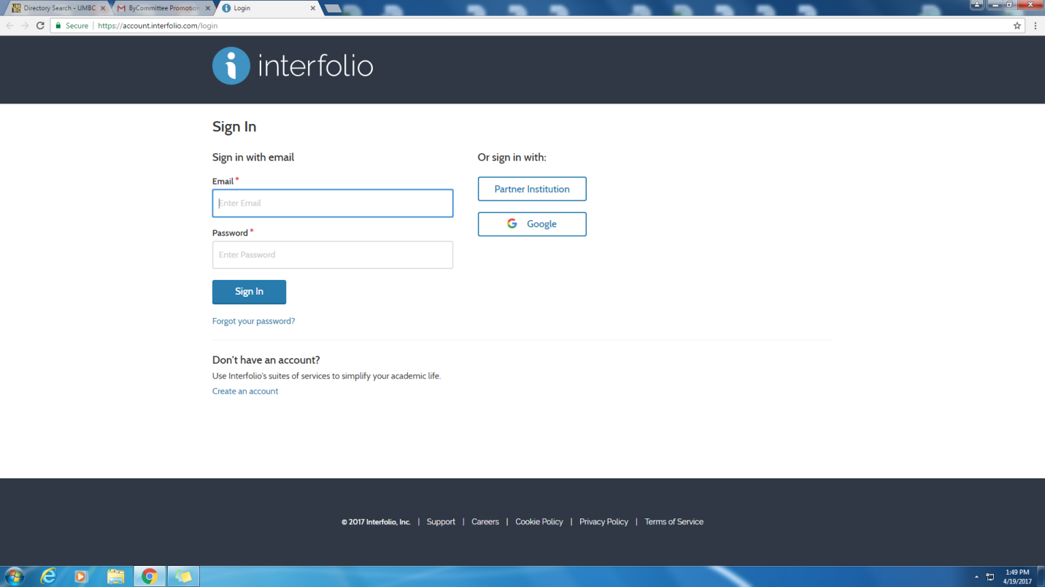

Step 3: Candidate Visits “My Packet Section” and Selects “View”

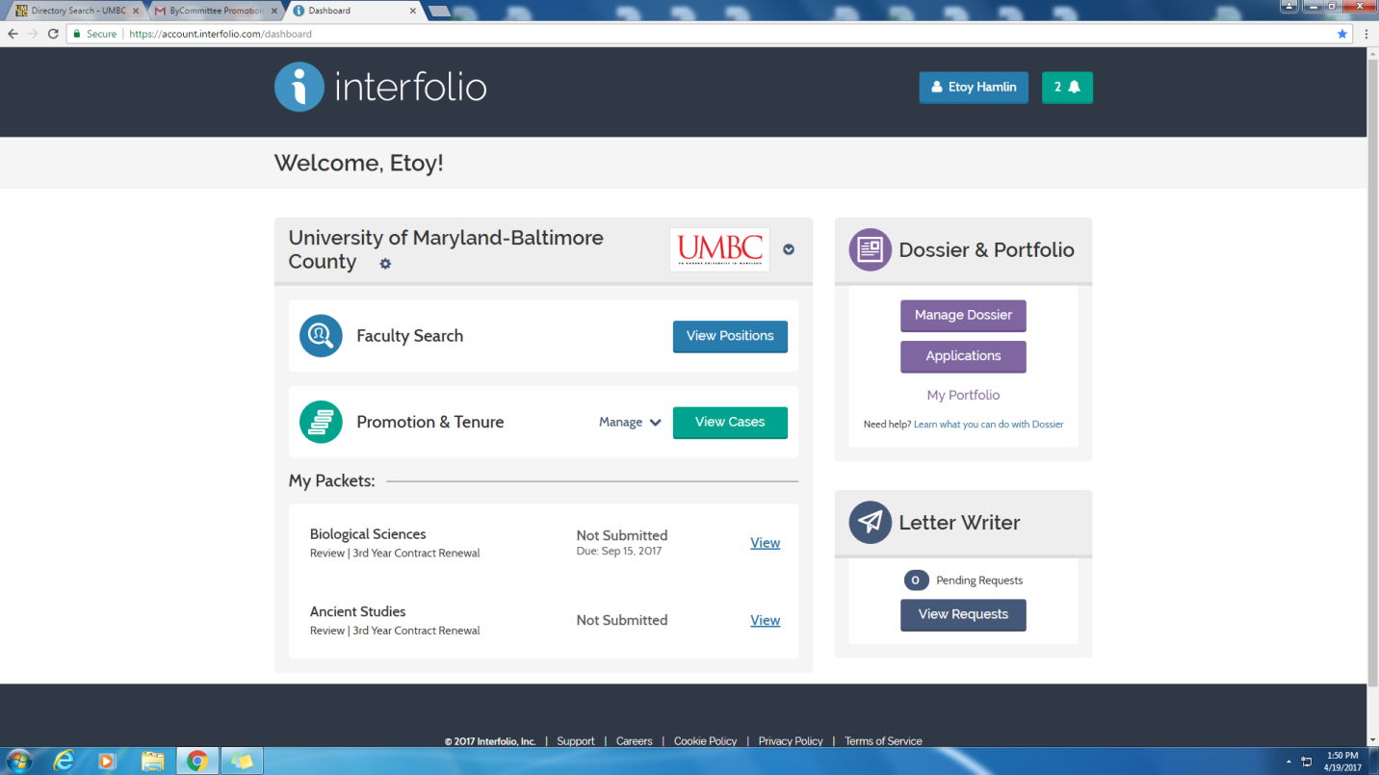

Step 4: Candidate Reviews Needed Documents and Selects “Work on Packet”

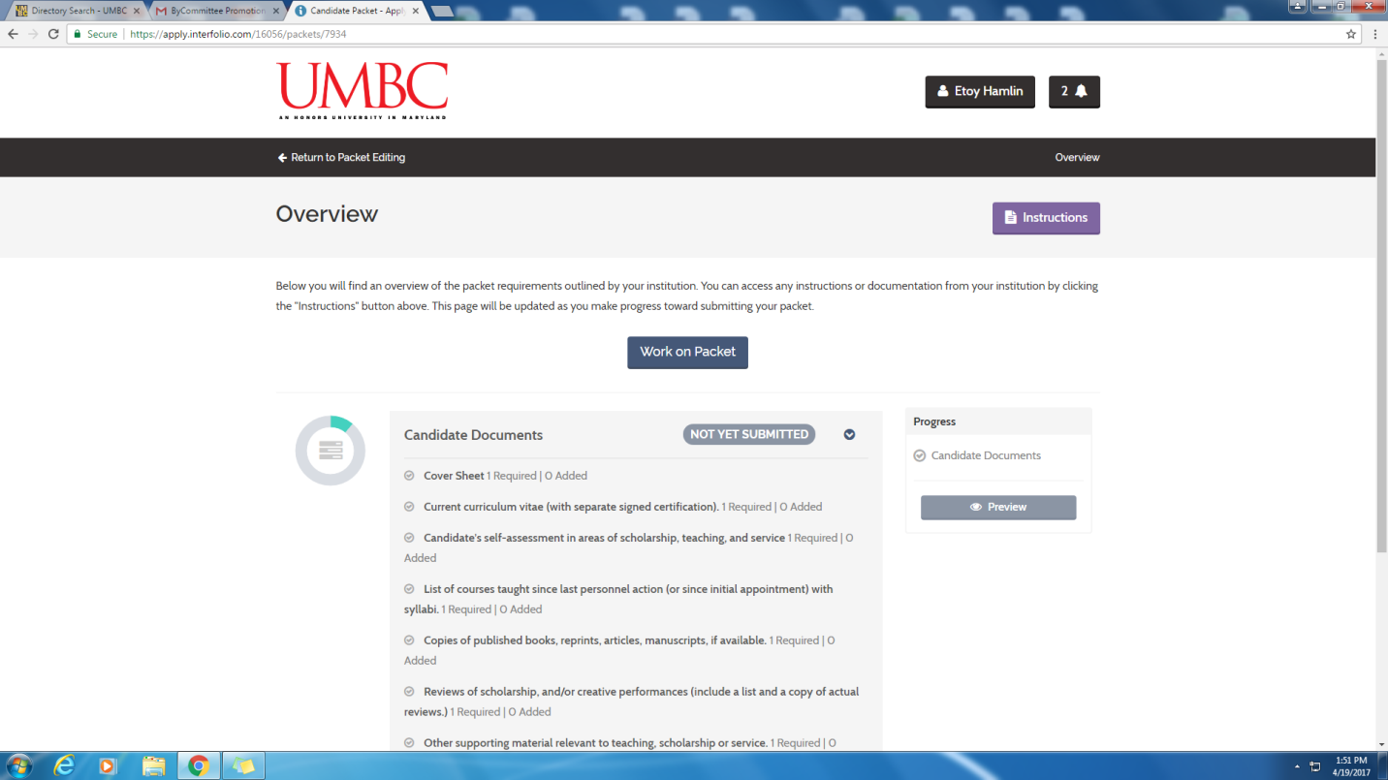
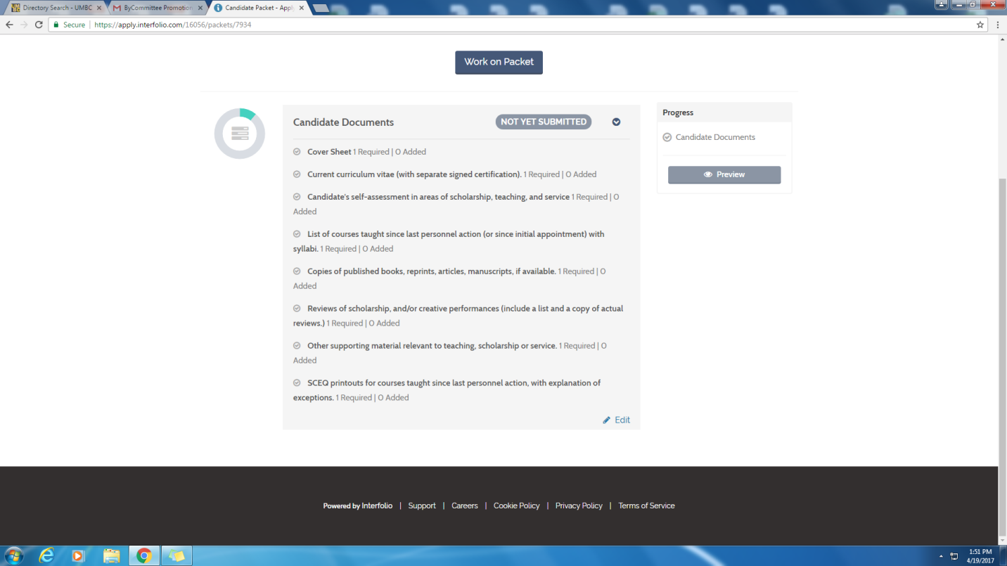

Step 5: Candidate Uploads Files

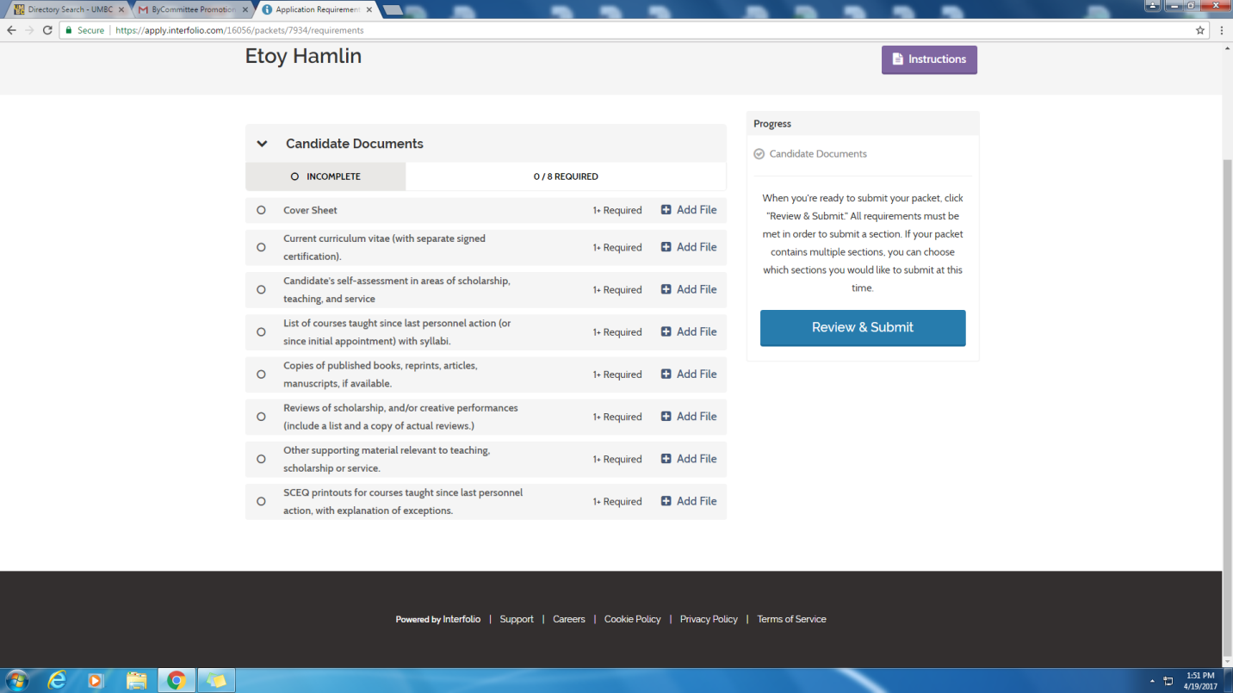

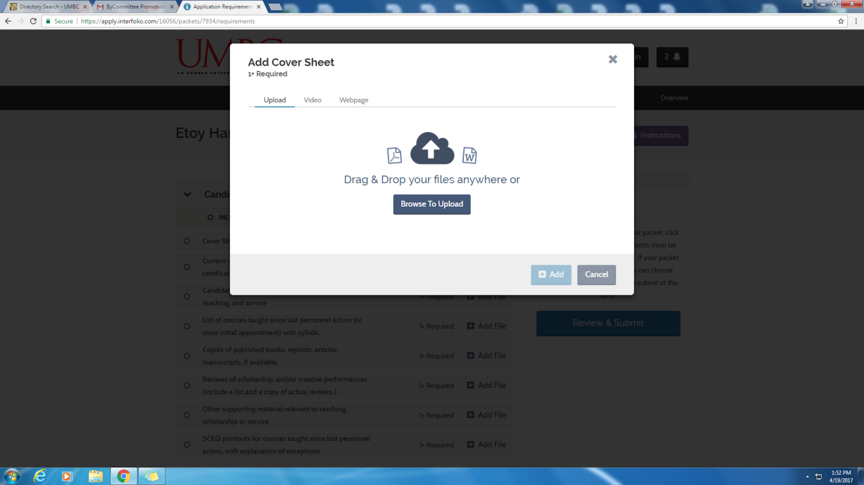

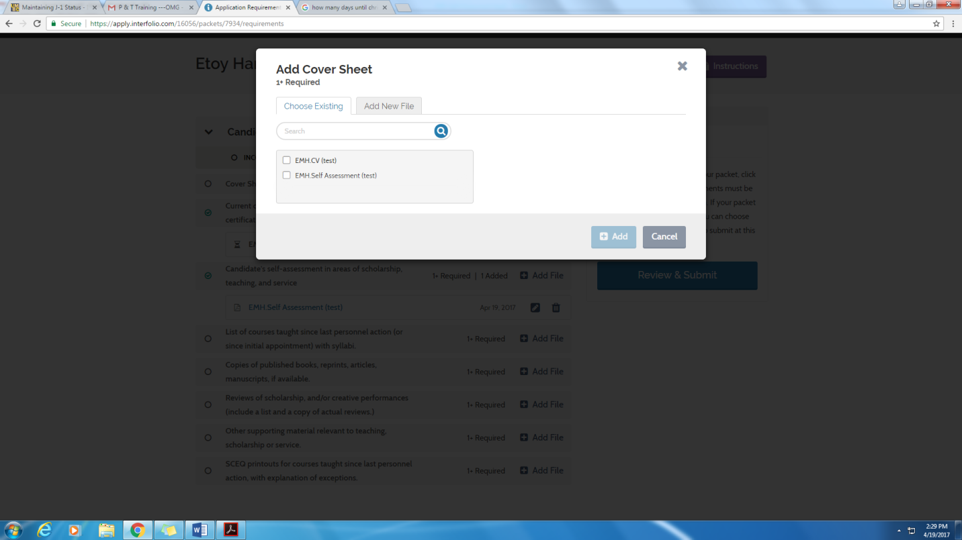
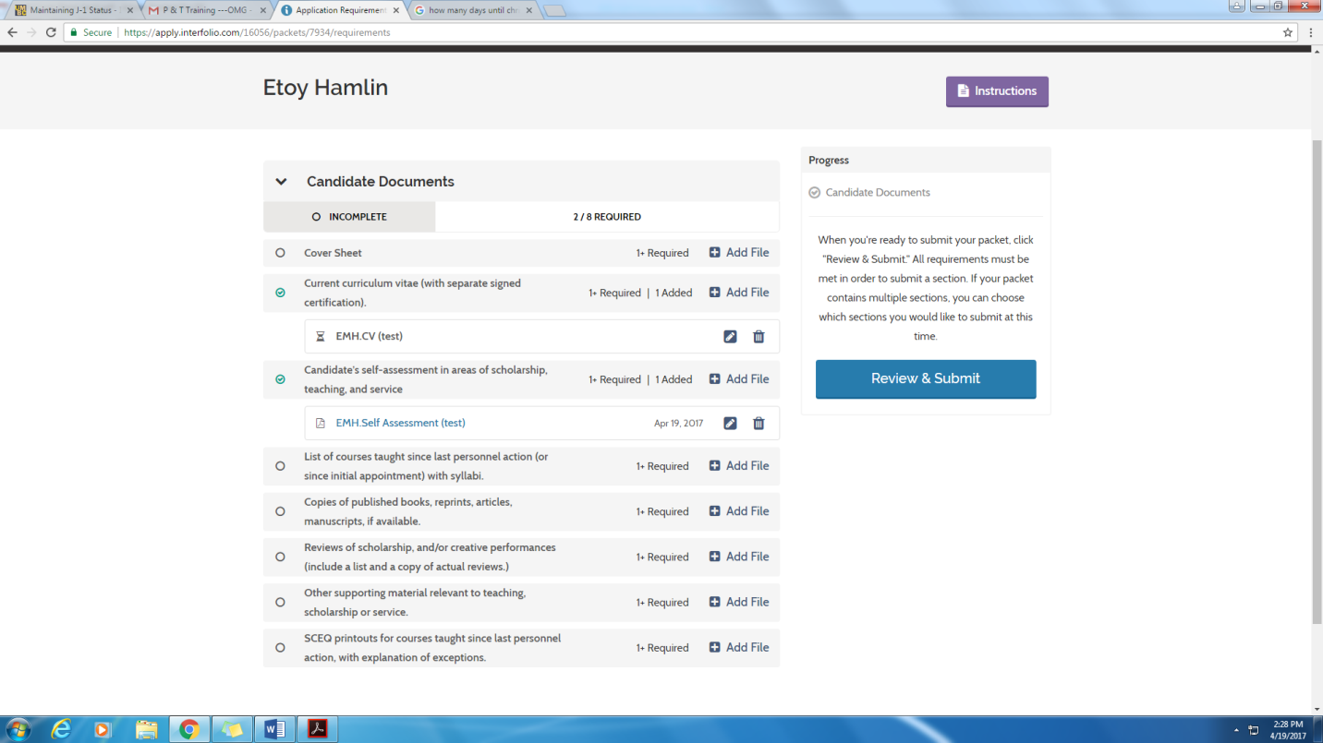

Step 6: After Uploading All Files (all files do not have to be uploaded at once, candidates can return to finish), Candidate Clicks, “Review and Submit”
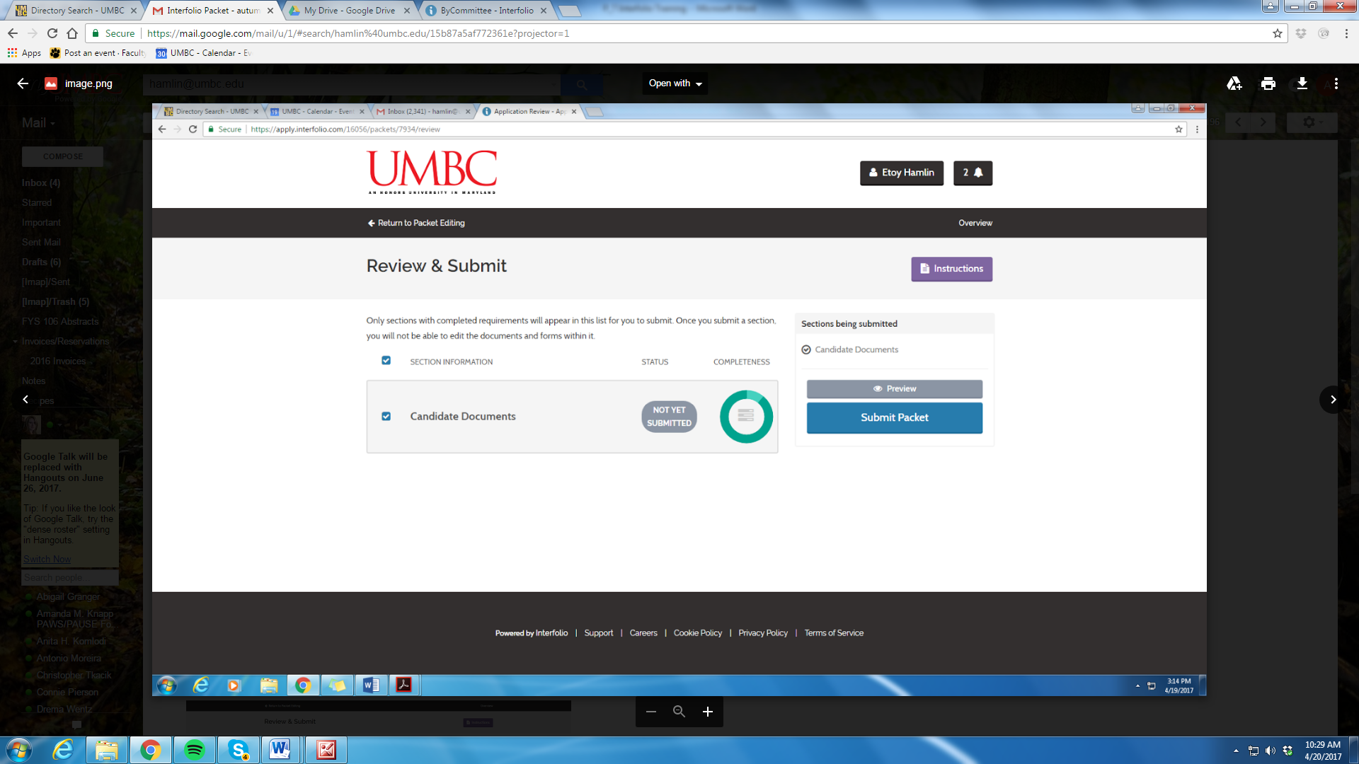

Step 7: Candidate Receives Submission Notice

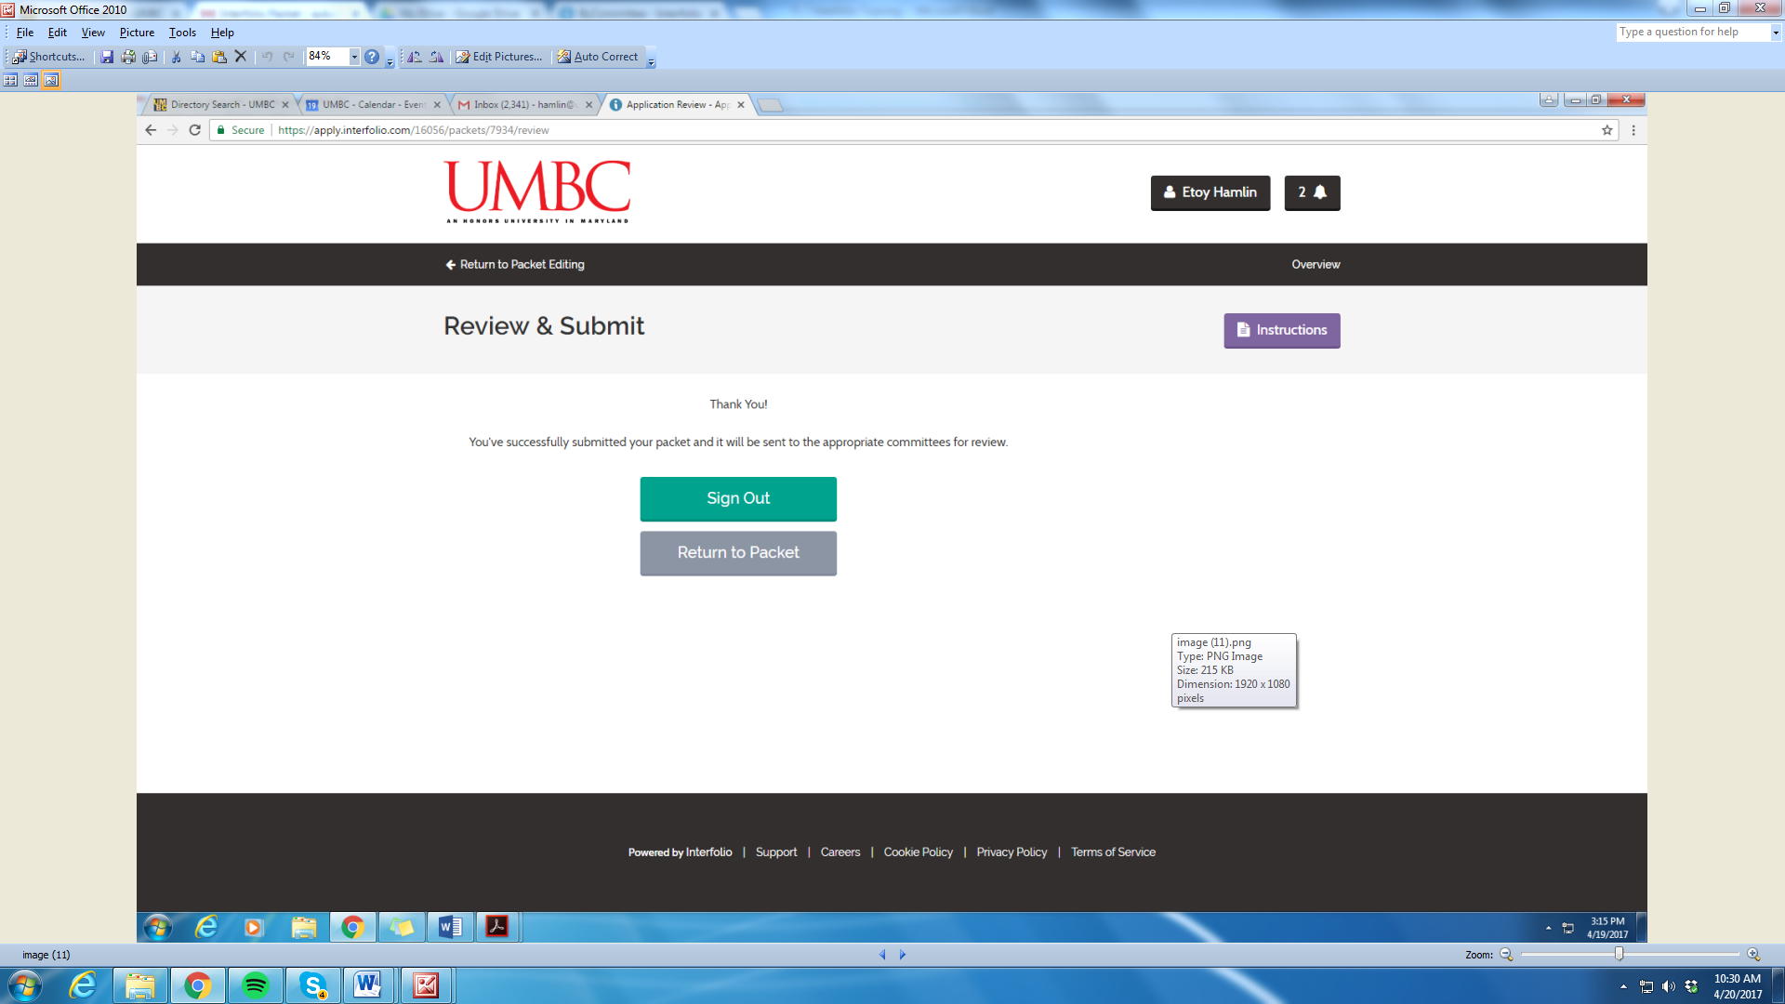

- Committee(s) Review

Step 1: After the candidate has submitted packet (dossier), the case step will update to “Step 1 of 5 Department Review.”

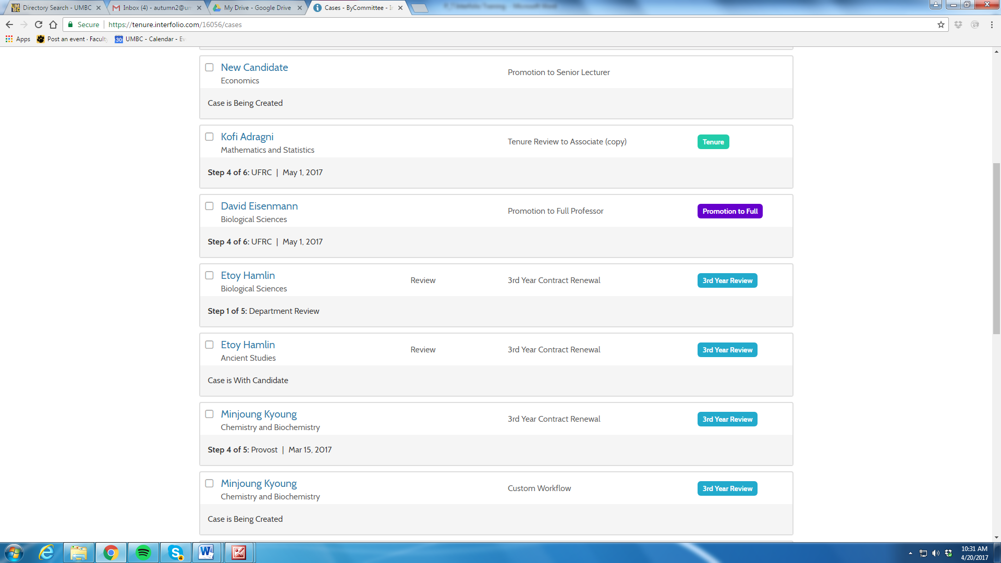

DP&TC Committee Members Receive this Email

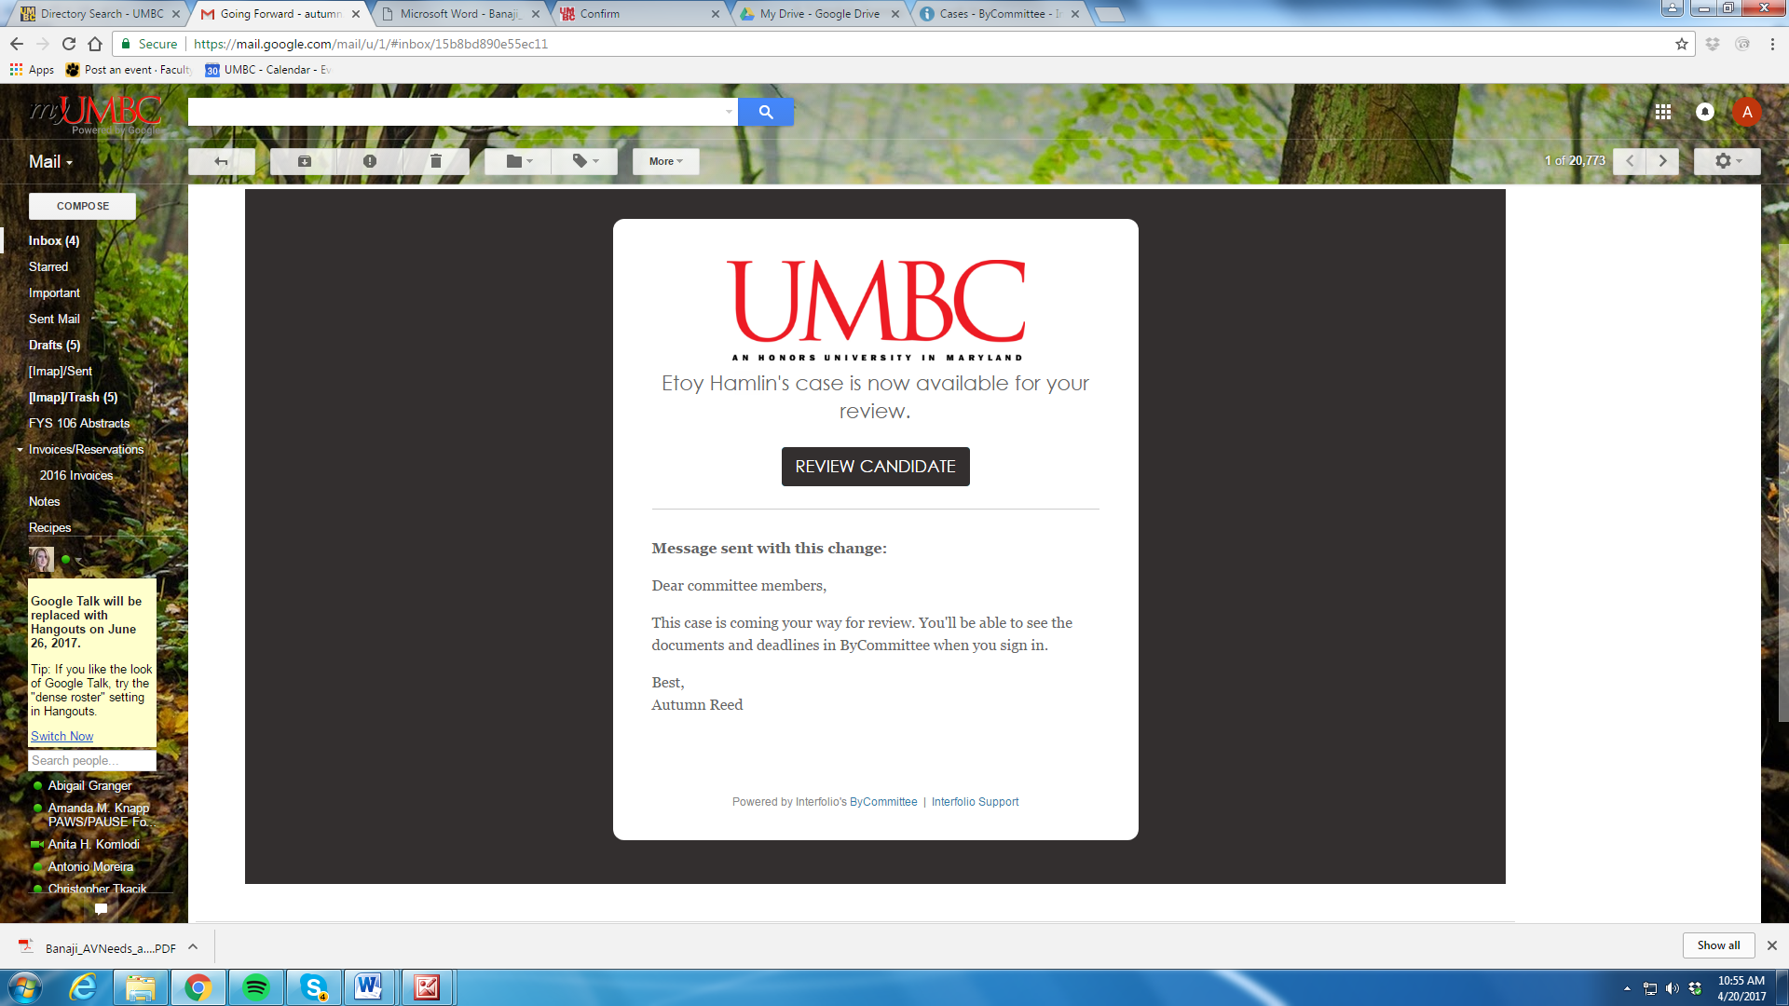
Step 2: DP&TC Members Log into Interfolio and Access Cases that they are reviewing

Step 3: DP&TC Members Review Cases
You can access files individually or use the “Read” function as in Faculty Search to review materials in Adobe and move from section to section.
APPLICATION CANNOT BE DOWNLOADED-OPTION DOES NOT EXIST
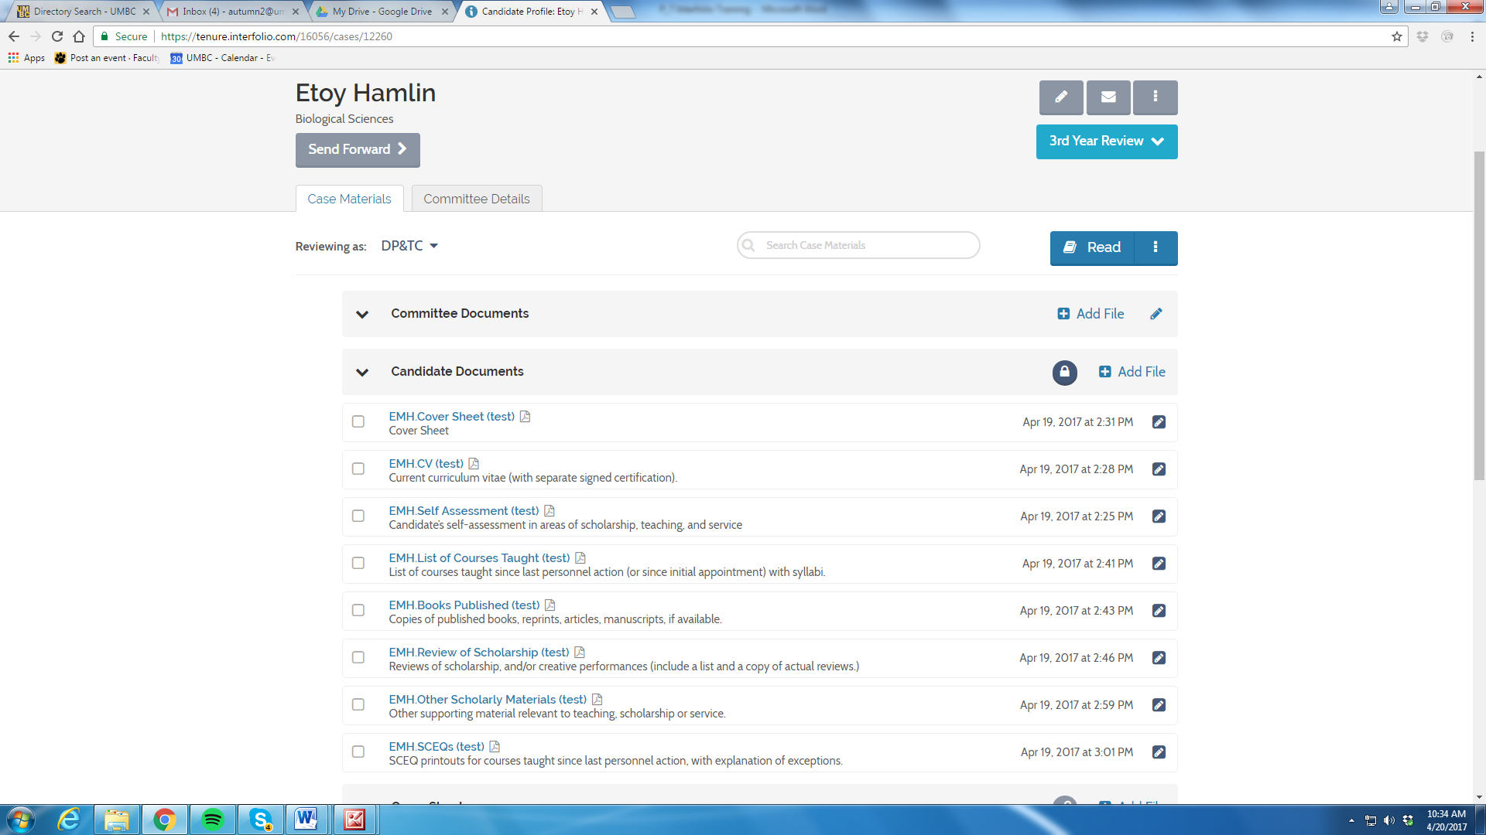
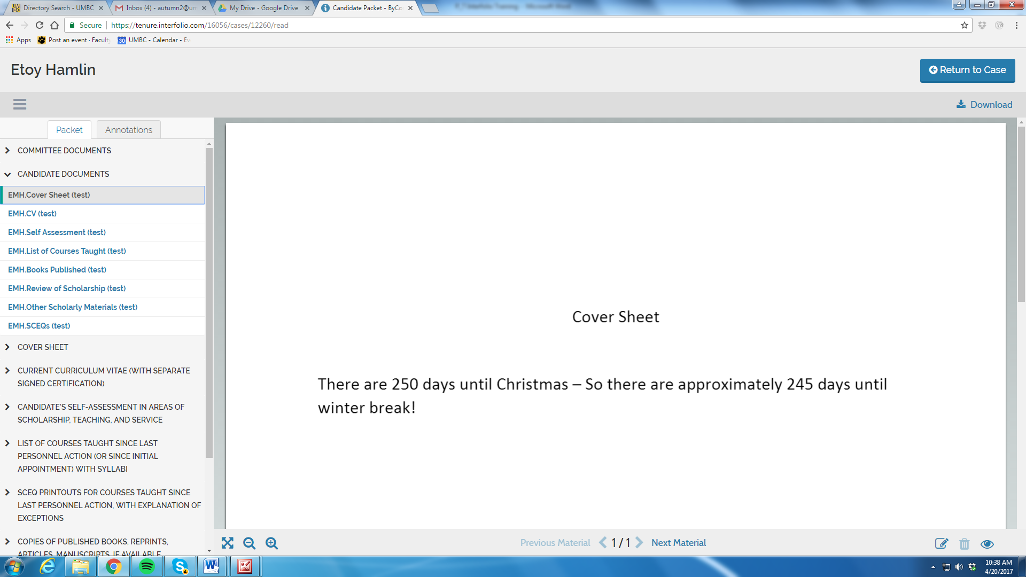

DO NOT USE THE ANNOTATION FUNCTION
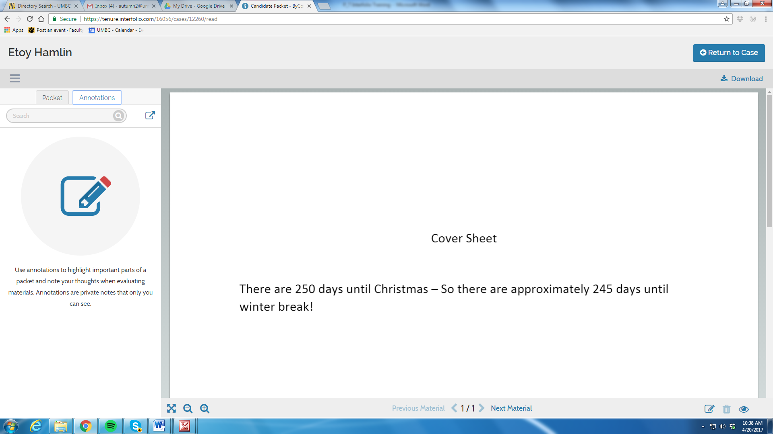

Step 4: The DP&TC Committee meets, deliberates, votes

Step 5: The Committee Manager/Administrative Assistant records the vote by clicking on the “Committee Details” tab.

Select Voting
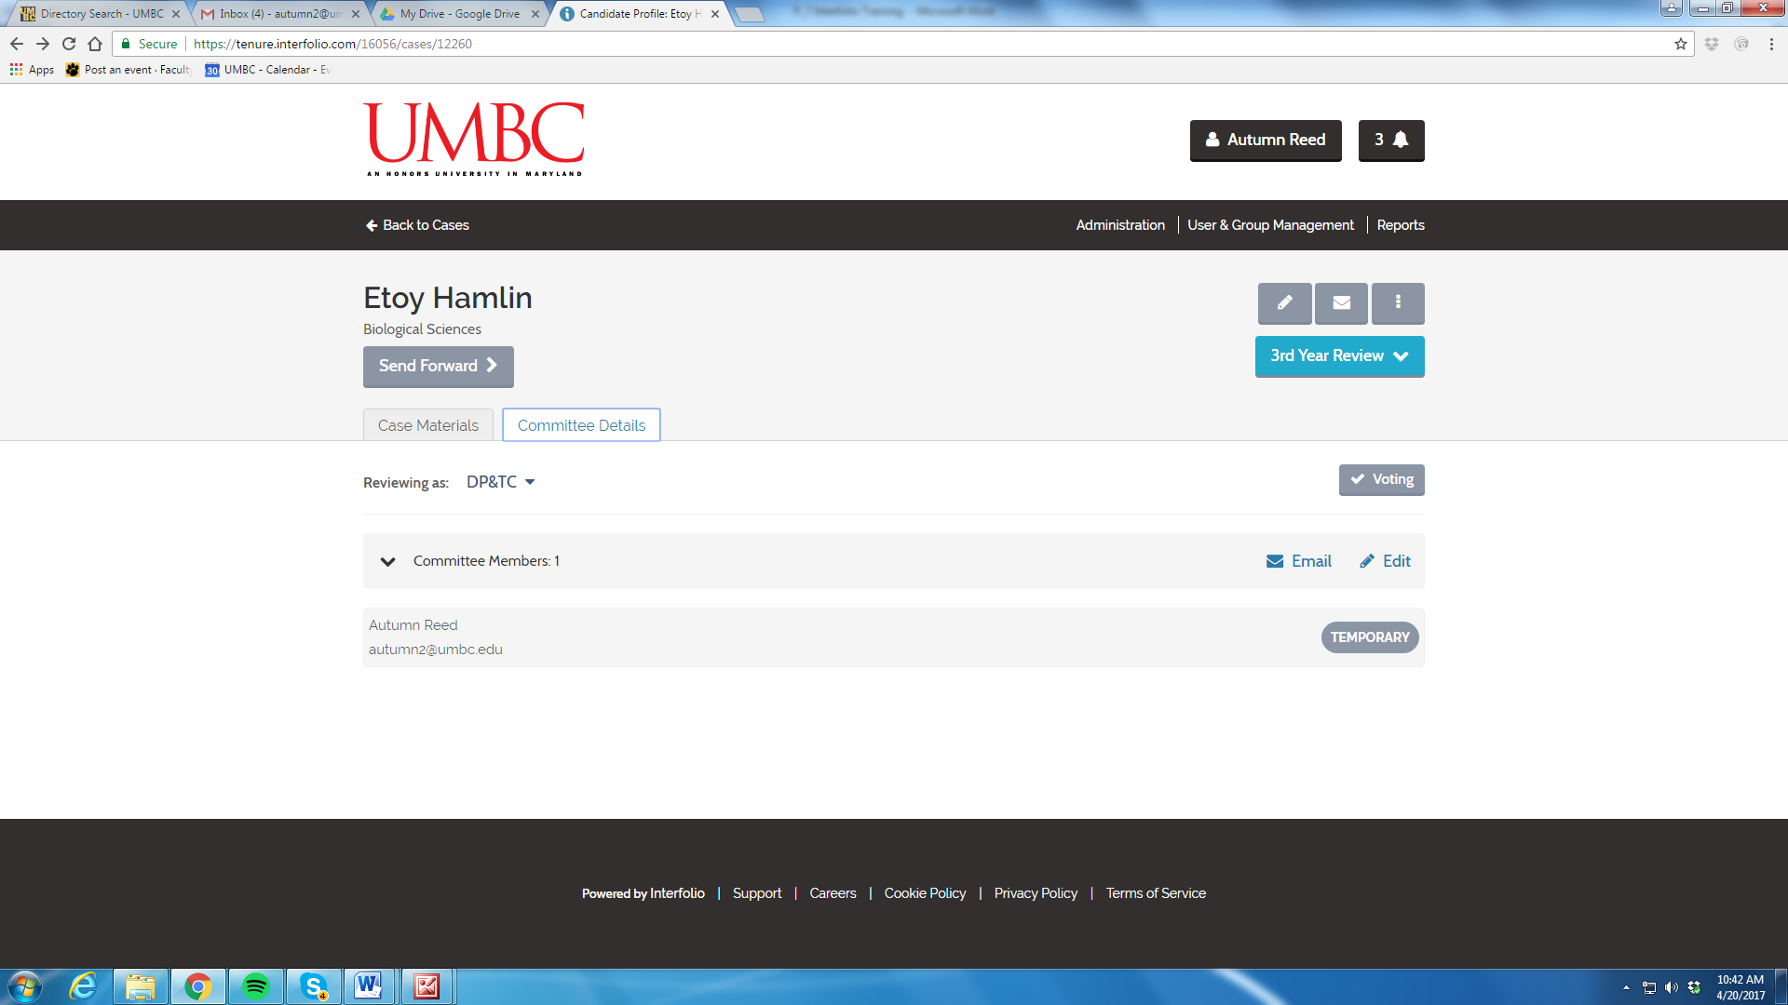

Record Vote

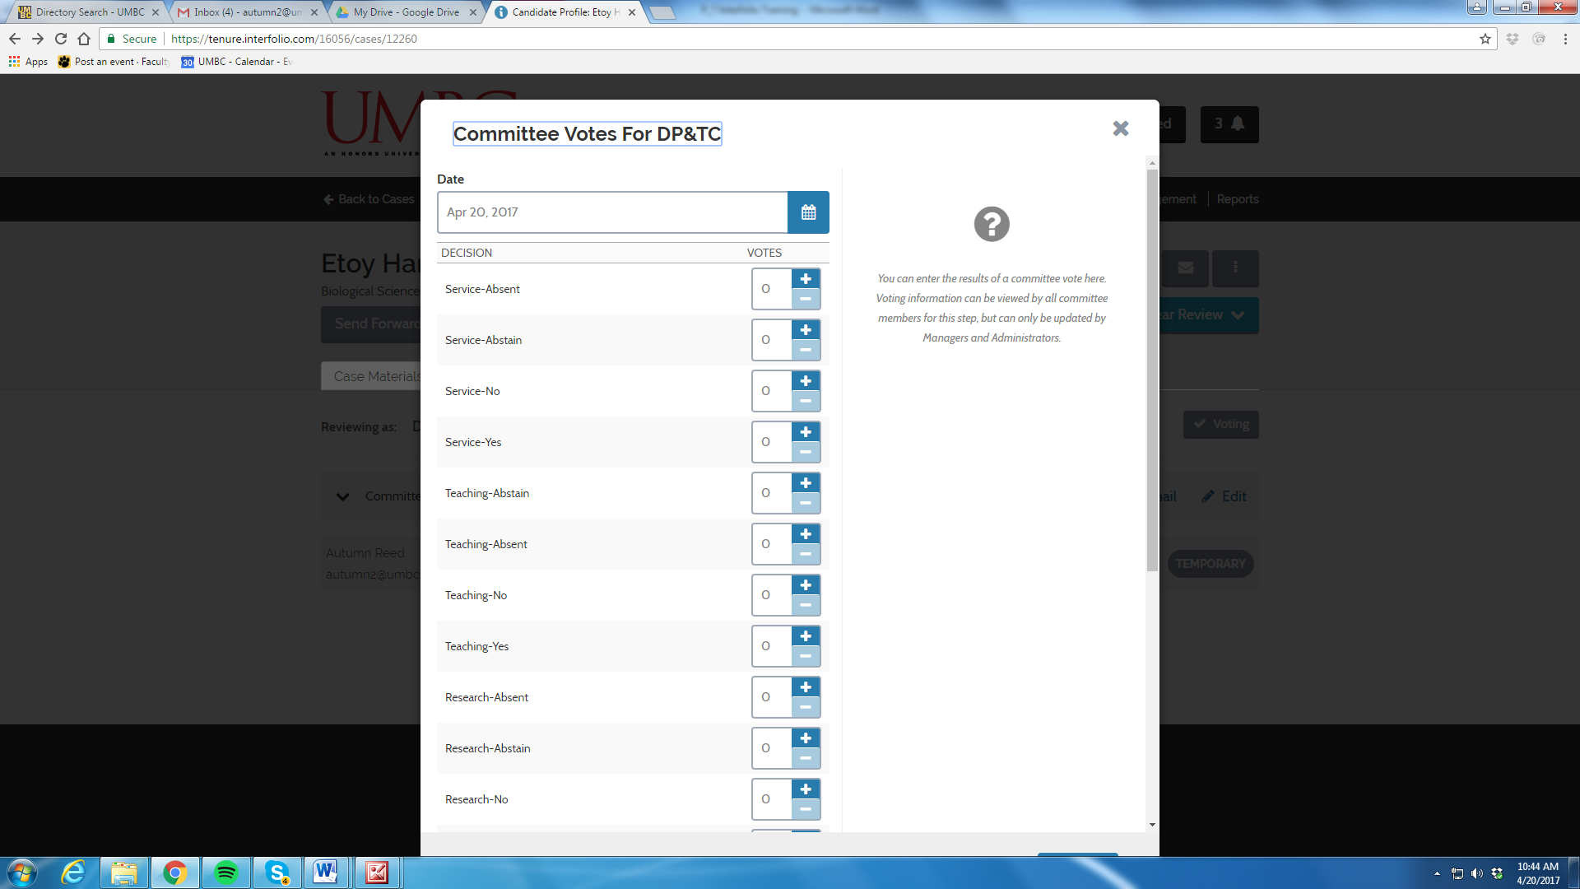

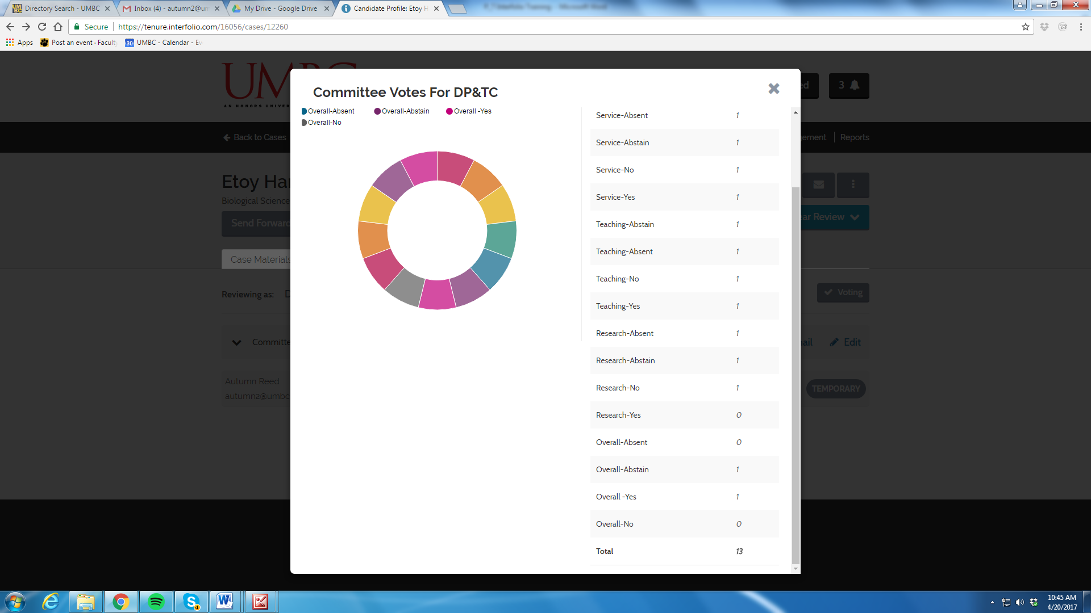

Step 6: Committee Manager/Administrative Assistant uploads the Report by clicking on the “Case Materials” tab and then clicks “Add File”
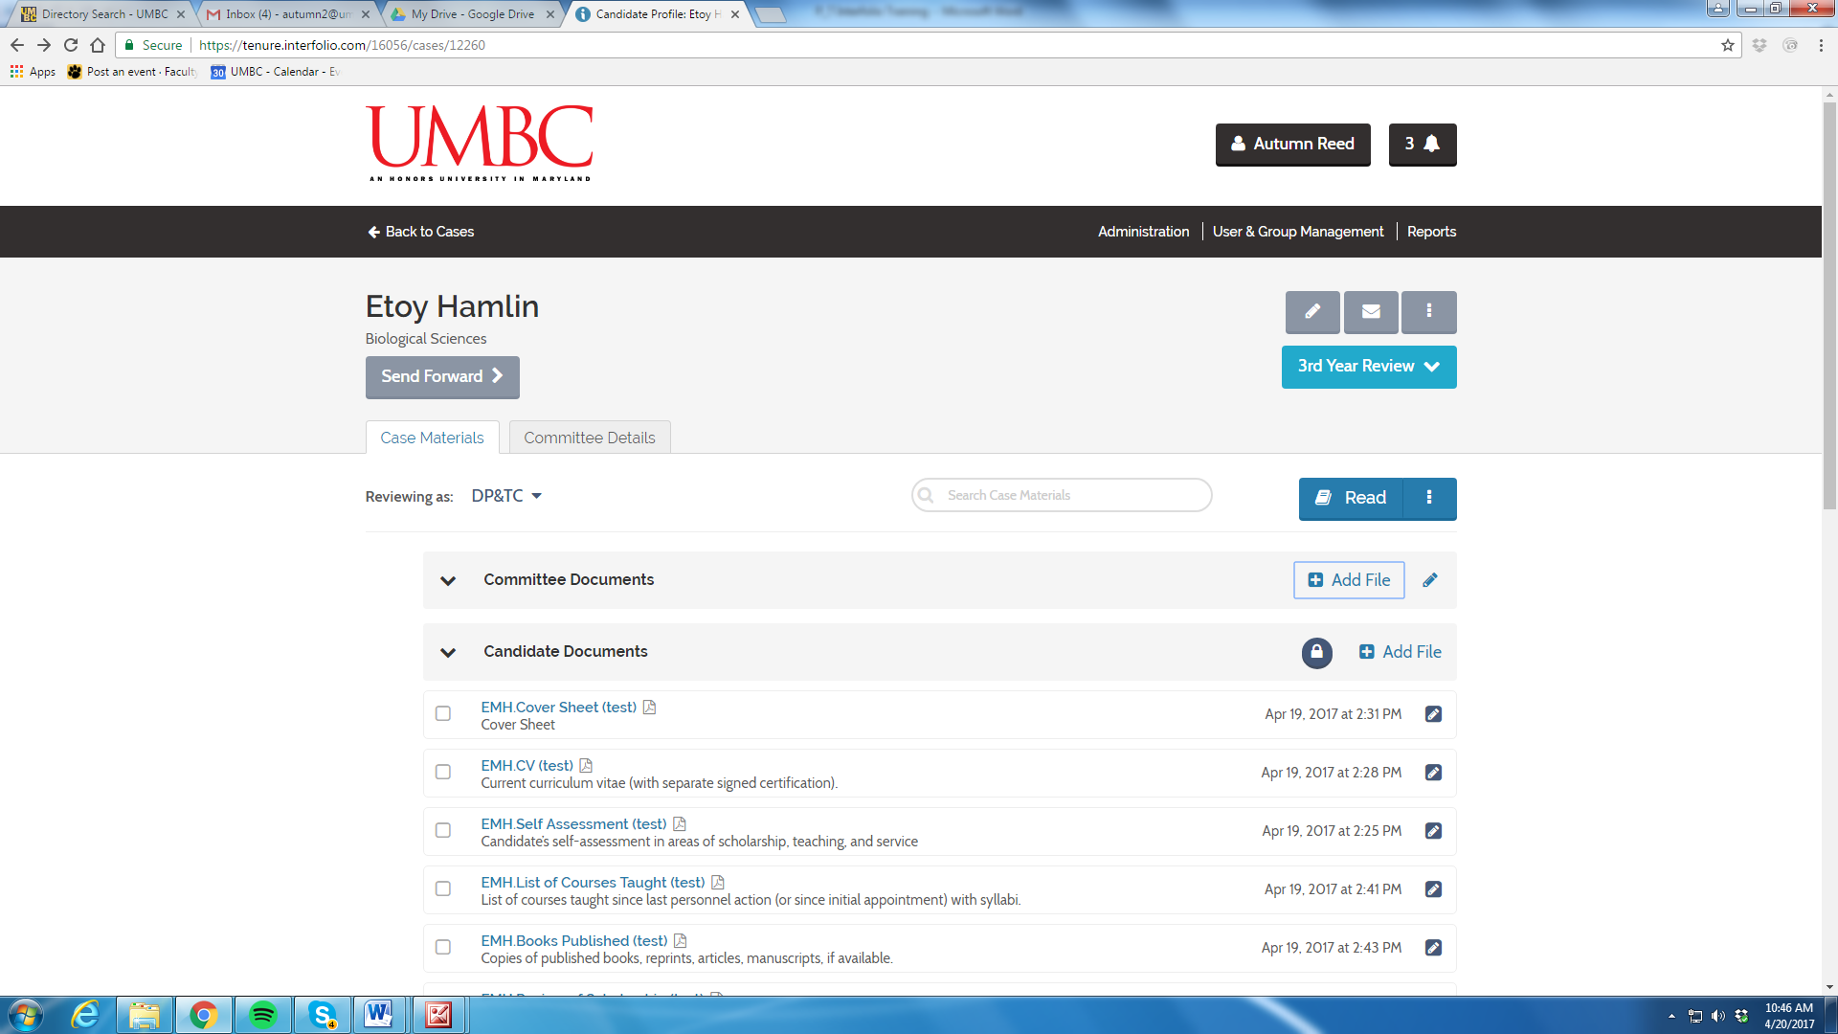
2
1

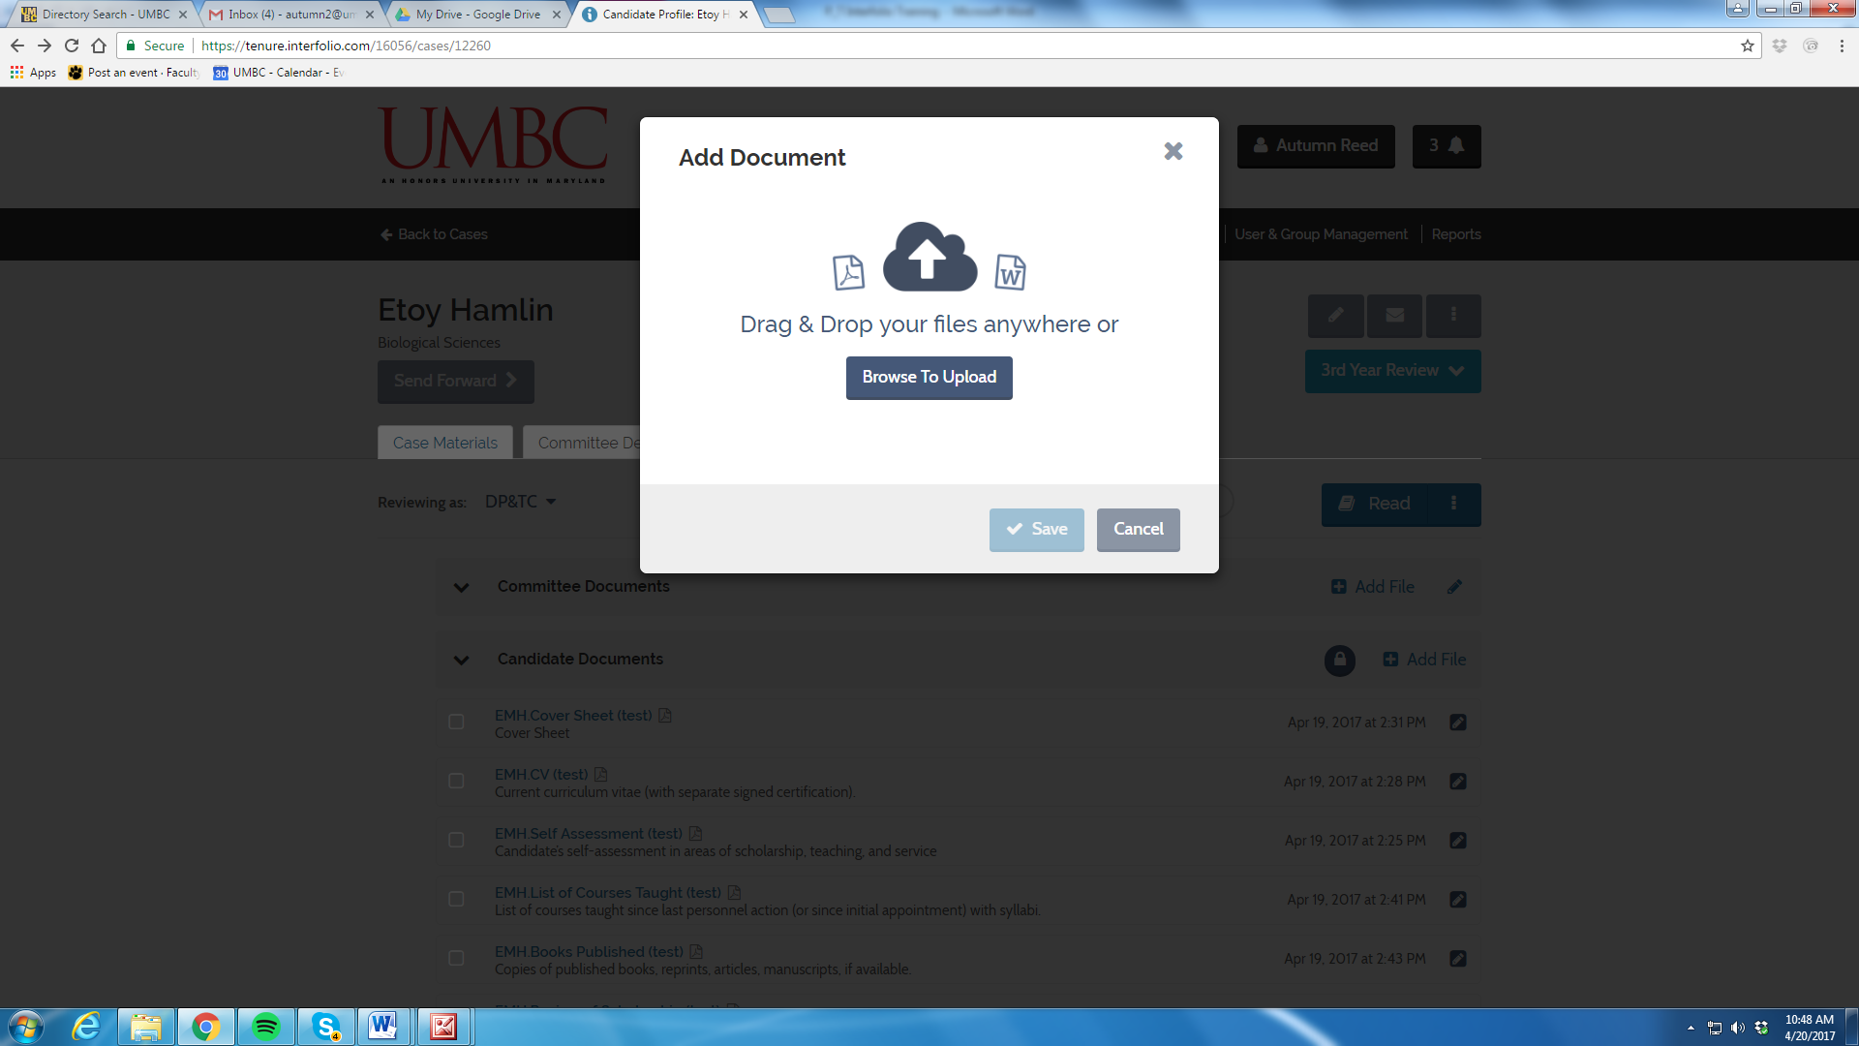

Step 7: Committee Manager/Administrative Assistant send the case forward to the next level of review, at this point the DP&TC no longer has access to the case. In the event the DP&TC needs to make a correction or add something the next level of review can send the case back.
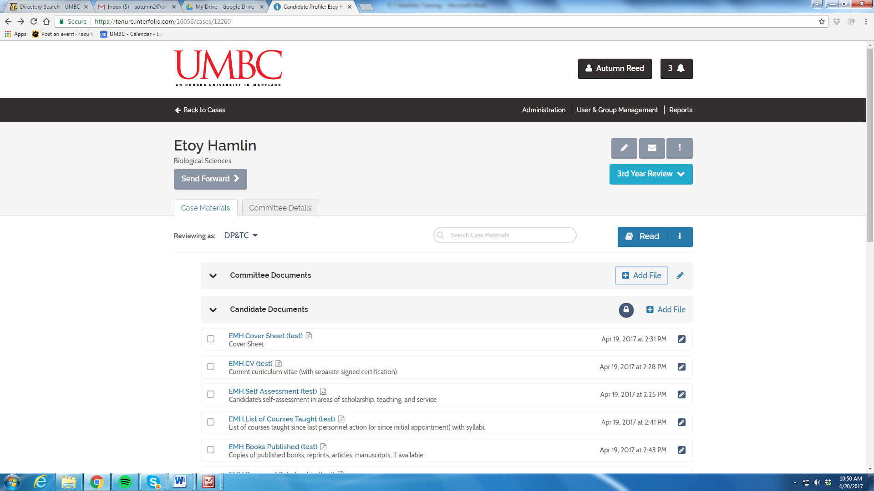
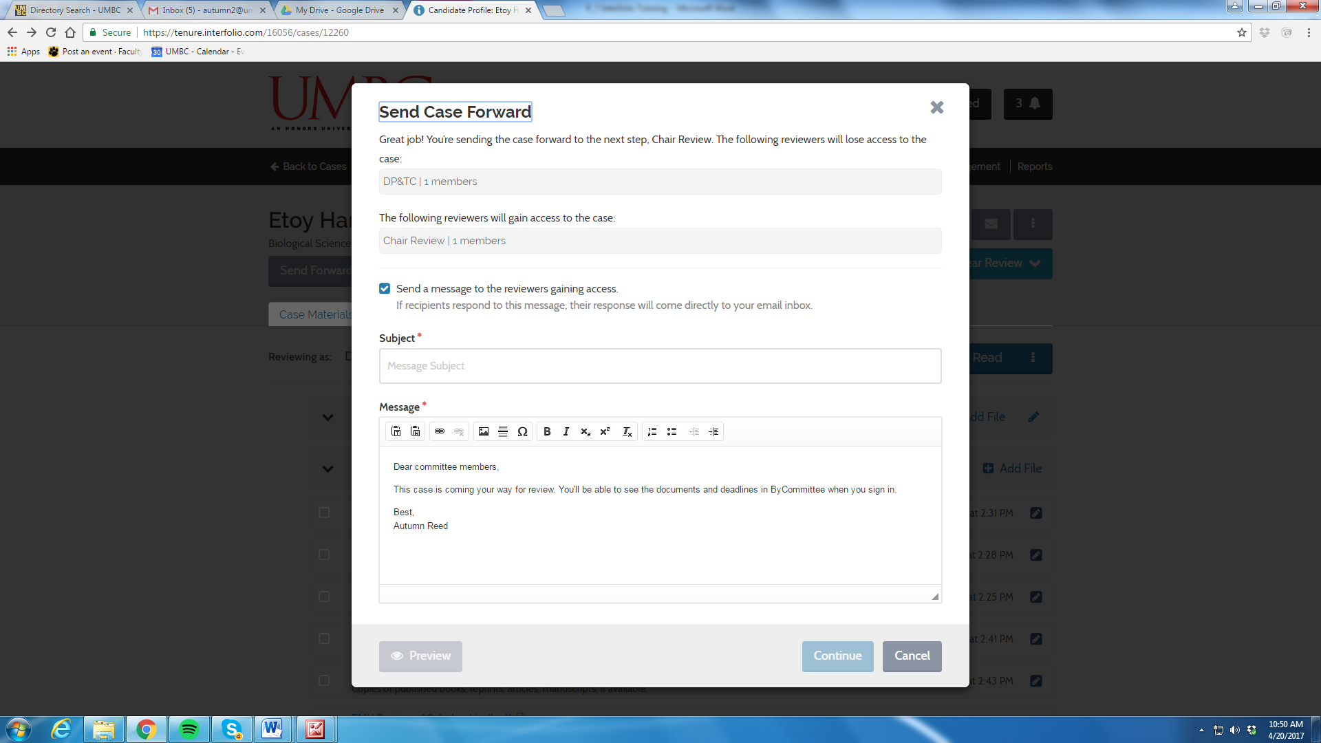

Step 8: Case is now with the Chair for Review
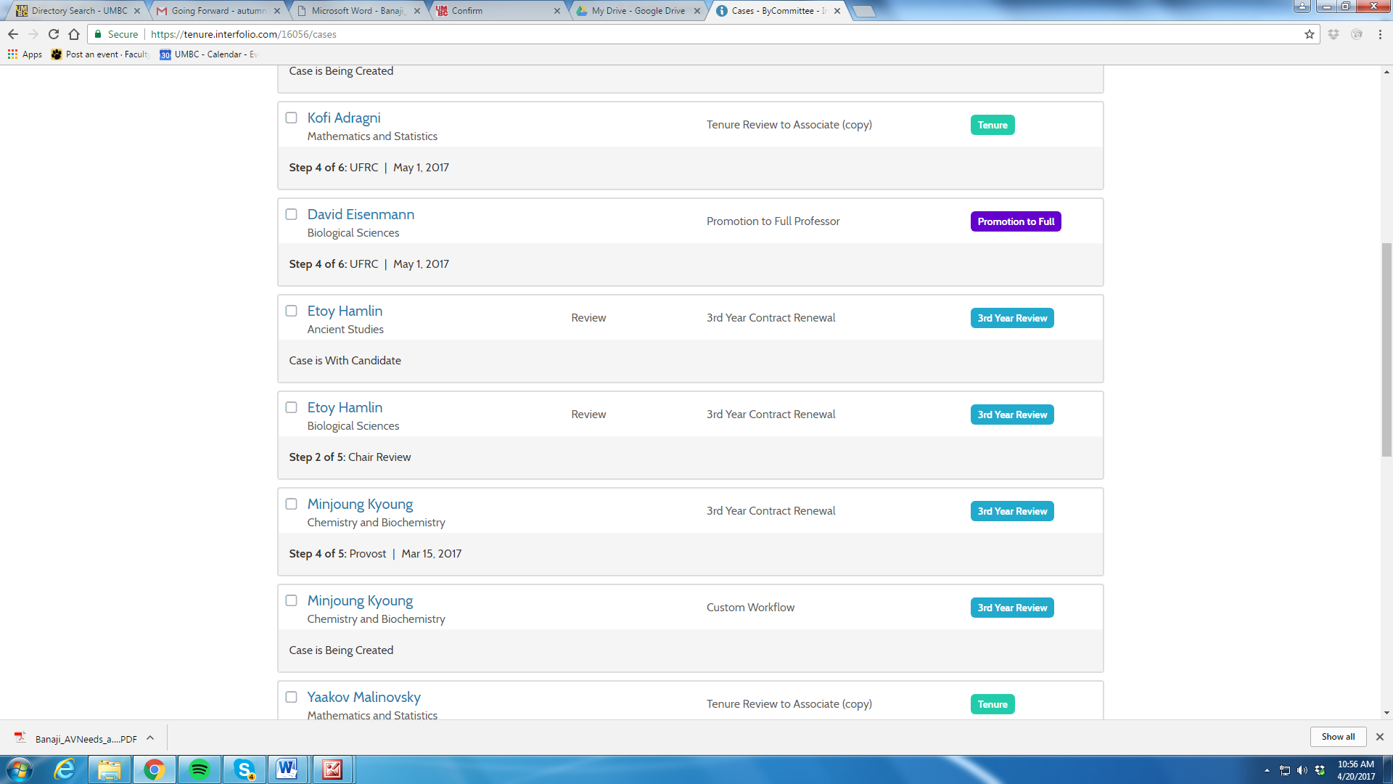

If the Chair needed to send the case back to the DP&TC they would click “Send Backward”
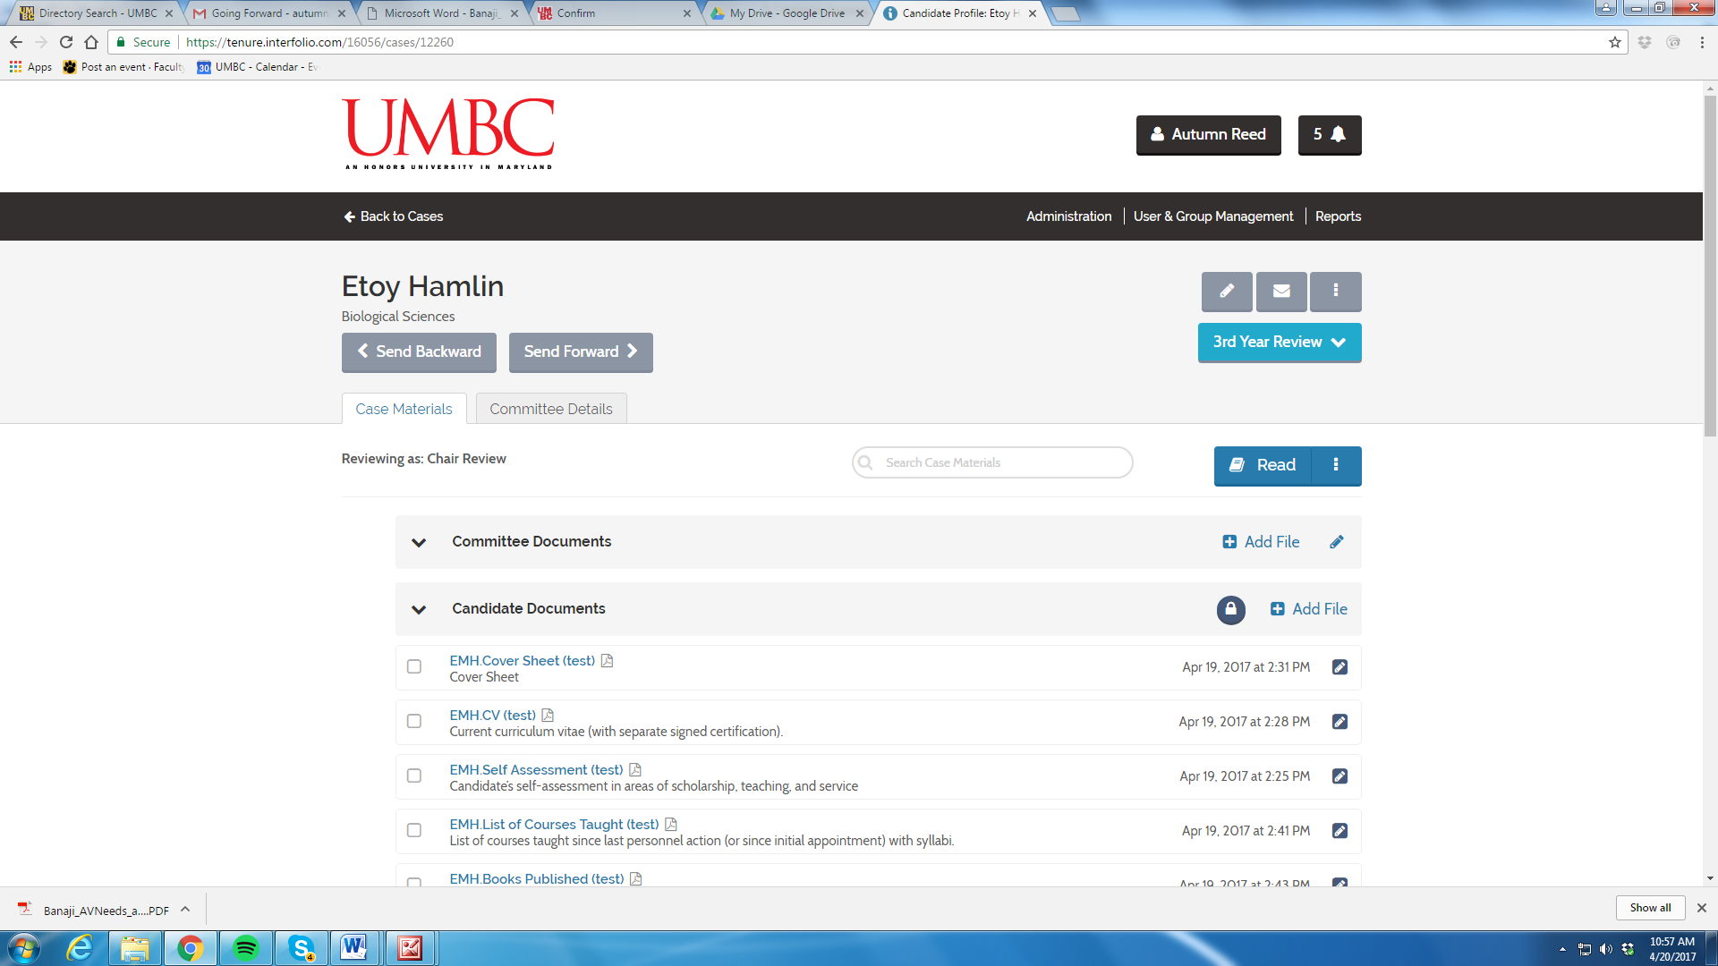

After the Chair Review, the Chair will upload their letter and send the case forward to the next level of review
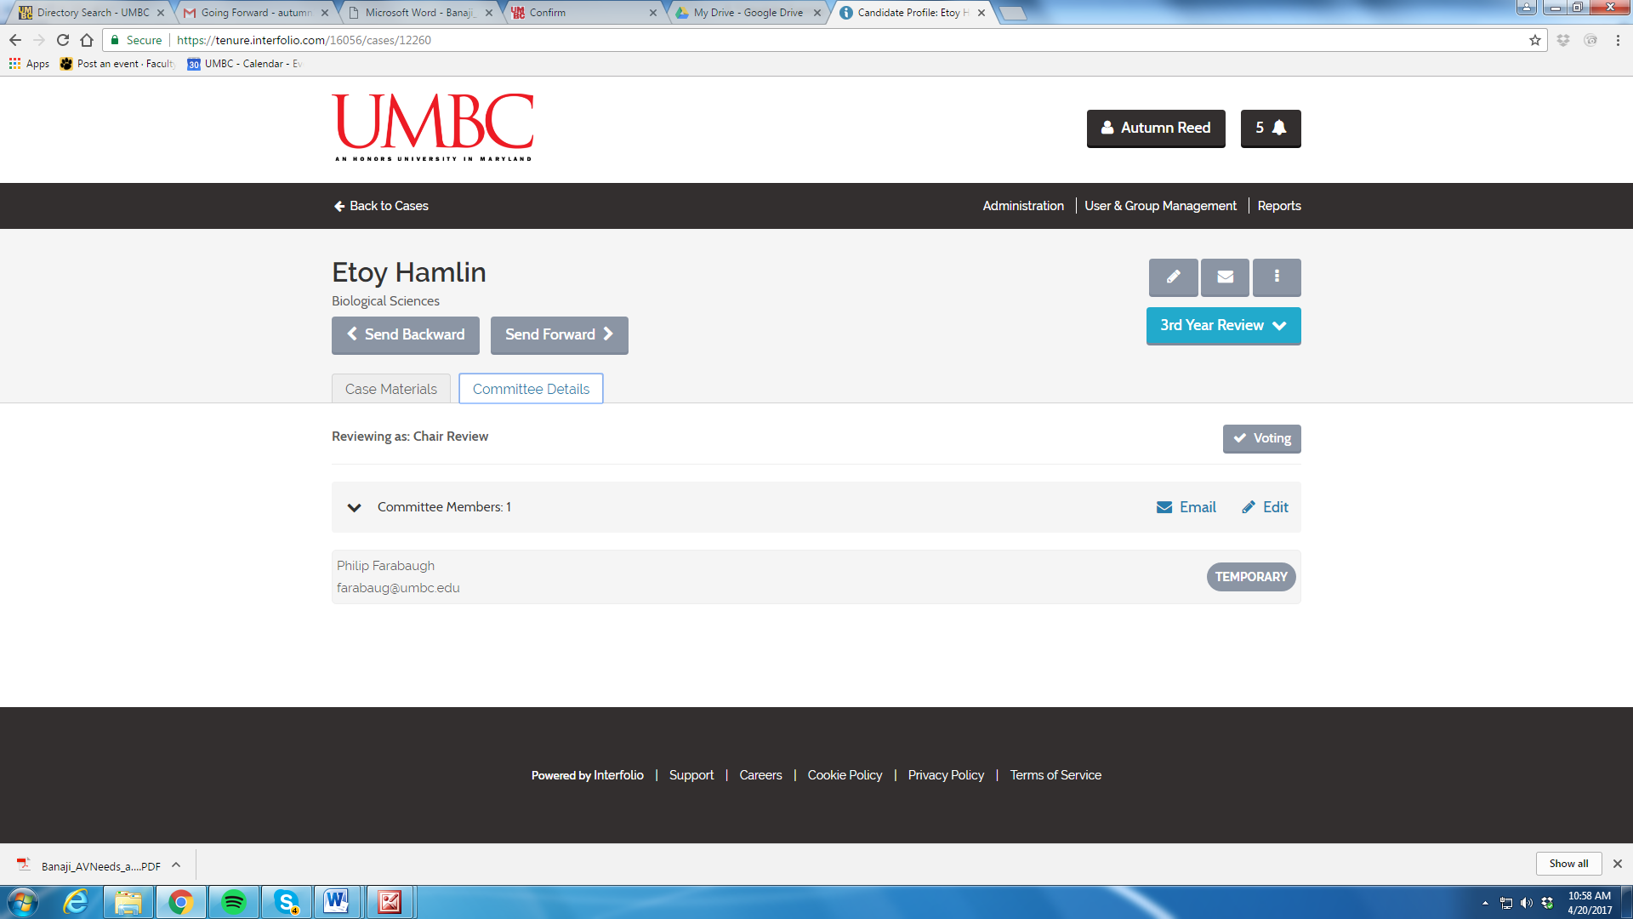

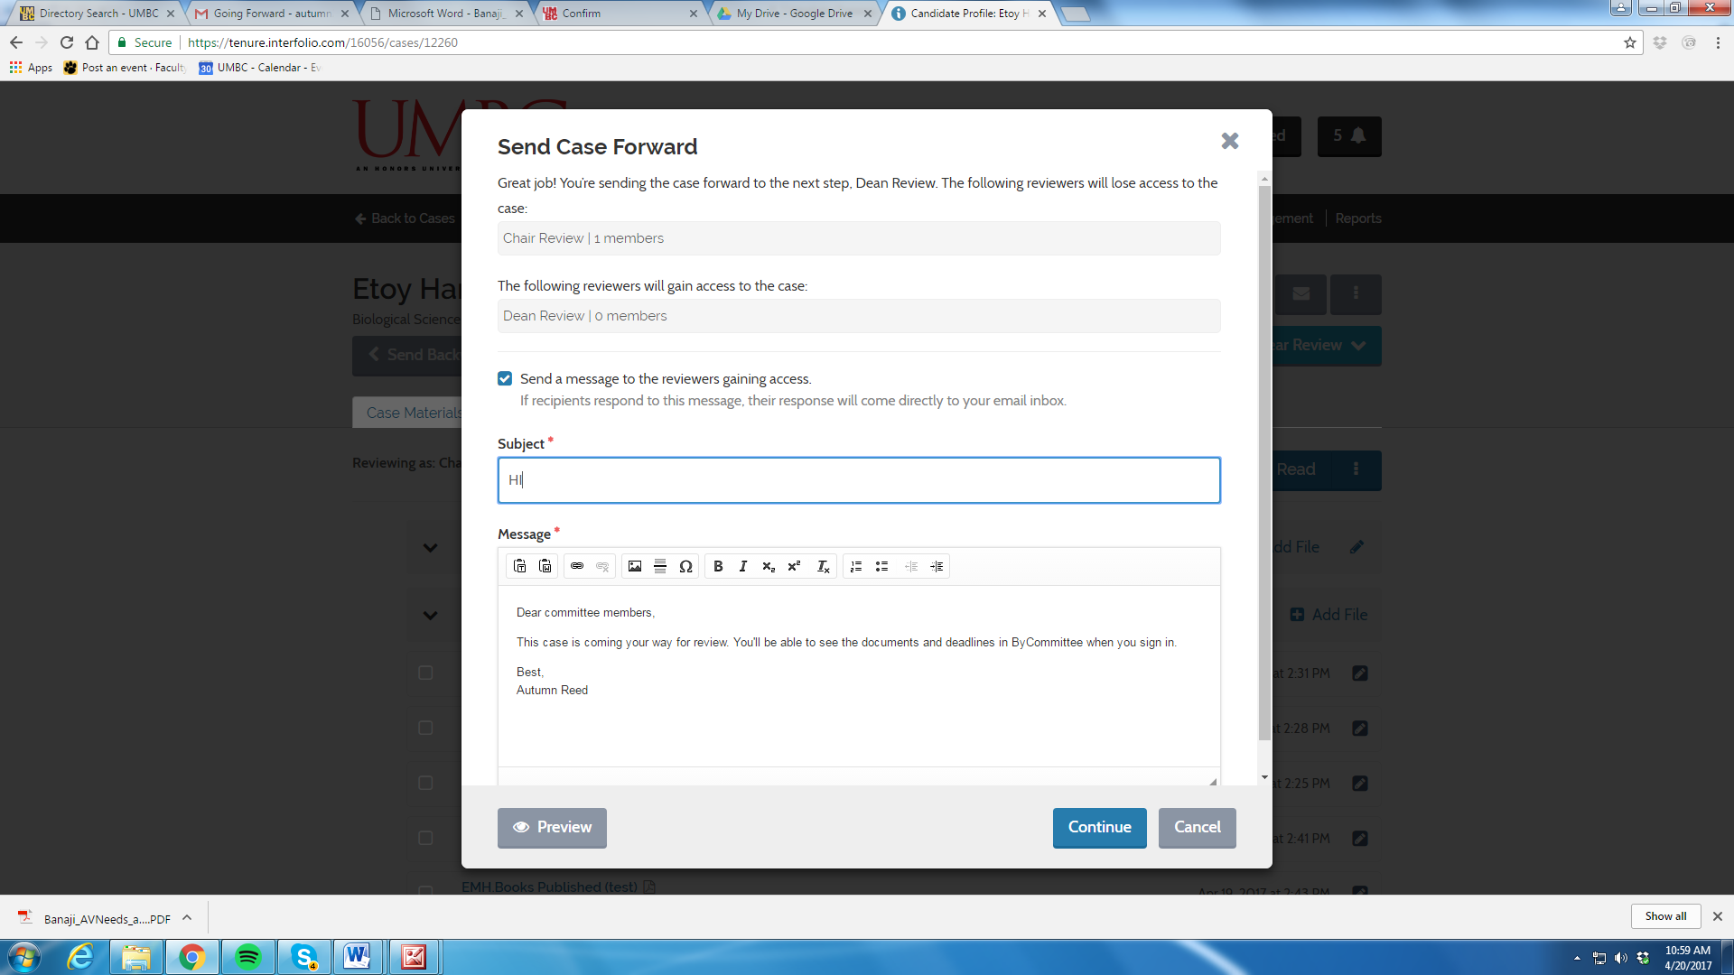

Step 8: Deans Review-Same Steps Apply
Dean is able to review the packet (dossier), the DP&TC report, votes, the Chair Report.
The Dean completes their review and adds their report and sends the case forward

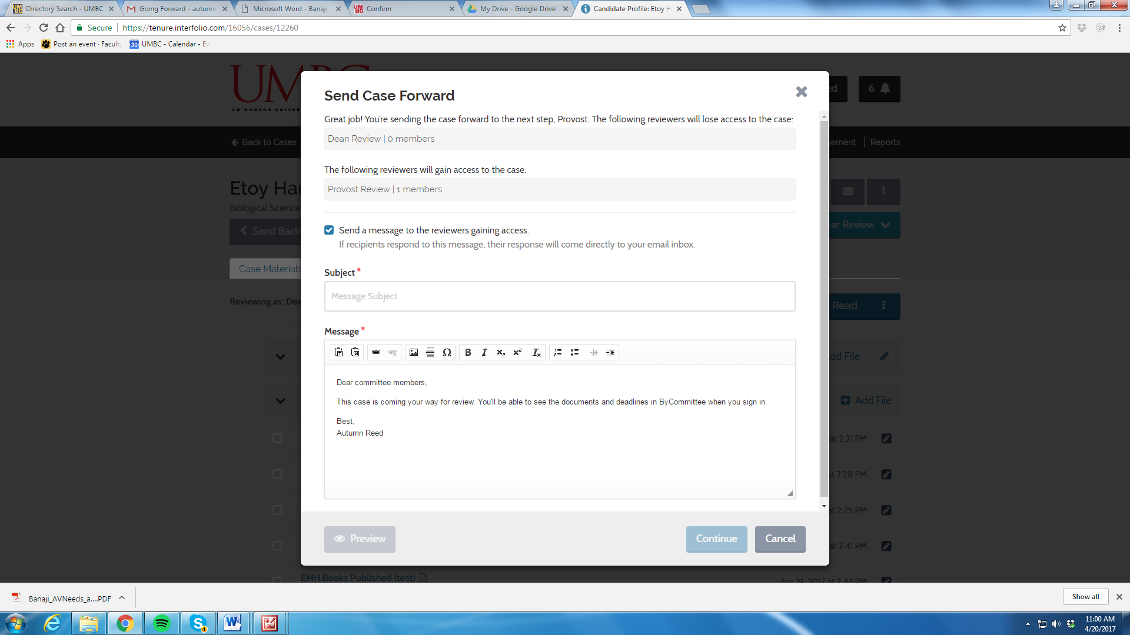

- Interfolio Dossier
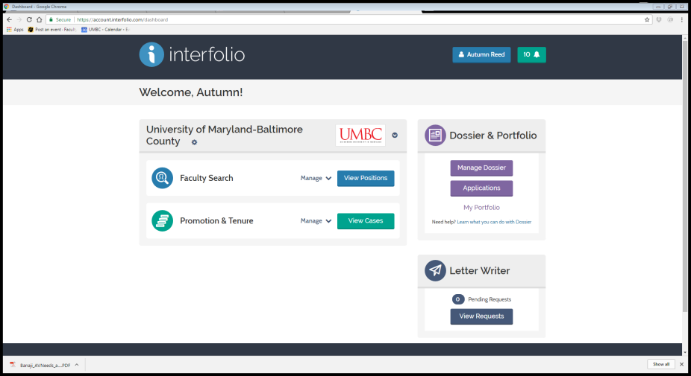
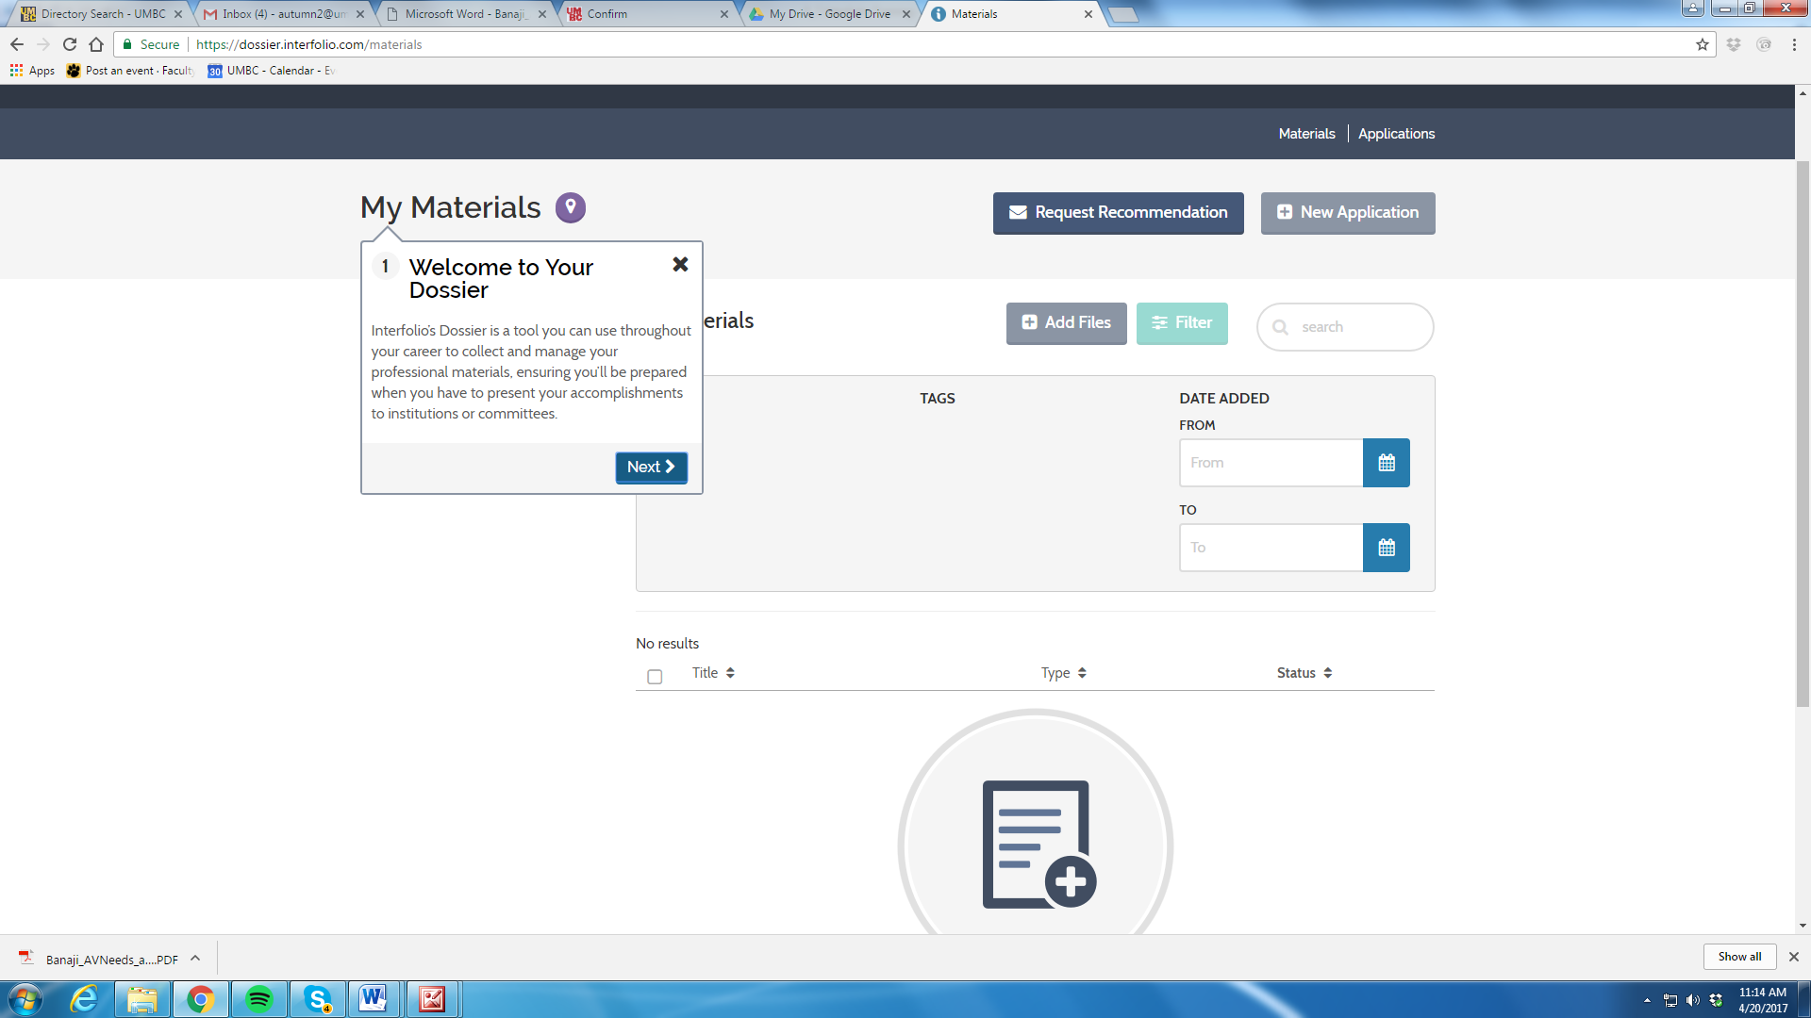

- Help Using Interfolio Product Guidelines

Step 1: Contact Interfolio’s Support Team at 887-997-8807

Step 2 (If Needed): Contact Deans Office

Step 3 (If Needed): Deans Office with Contact Provost Office for Assistance.

